UNITED STATES

SECURITIES AND EXCHANGE COMMISSION
WASHINGTON, D.C. 20549

FORM 8-K

CURRENT REPORT

Pursuant to Section 13 or 15(d) of the Securities Exchange Act of 1934

Date of Report (Date of earliest event reported): May 29, 2026

Palomar Holdings, Inc.

(Exact name of Registrant as Specified in Its Charter)

Delaware | 001-38873 | 83-3972551
(State or Other Jurisdiction | (Commission File Number) | (IRS Employer
of Incorporation) |  | Identification No.)
7979 Ivanhoe Avenue, Suite 500
La Jolla, California |  | 92037
(Address of Principal Executive Offices) |  | (Zip Code)

Registrant’s Telephone Number, Including Area Code: 619 567-5290

(Former Name or Former Address, if Changed Since Last Report)

Check the appropriate box below if the Form 8-K filing is intended to simultaneously satisfy the filing obligation of the registrant under any of the following provisions:

- Written communications pursuant to Rule 425 under the Securities Act (17 CFR 230.425)

- Soliciting material pursuant to Rule 14a-12 under the Exchange Act (17 CFR 240.14a-12)

- Pre-commencement communications pursuant to Rule 14d-2(b) under the Exchange Act (17 CFR 240.14d-2(b))

- Pre-commencement communications pursuant to Rule 13e-4(c) under the Exchange Act (17 CFR 240.13e-4(c))

Securities registered pursuant to Section 12(b) of the Act:

 |  | Trading
Title of each class |  | Symbol(s) |  | Name of each exchange on which registered
Common Stock, par value $0.0001 per share |  | PLMR |  | The Nasdaq Stock Market LLC

Indicate by check mark whether the registrant is an emerging growth company as defined in Rule 405 of the Securities Act of 1933 (§ 230.405 of this chapter) or Rule 12b-2 of the Securities Exchange Act of 1934 (§ 240.12b-2 of this chapter).

Emerging growth company ☐

If an emerging growth company, indicate by check mark if the registrant has elected not to use the extended transition period for complying with any new or revised financial accounting standards provided pursuant to Section 13(a) of the Exchange Act. ☐

Item 7.01. Regulation FD Disclosure

On May 29, 2026, Palomar Holdings, Inc. (the “Company”) updated its corporate presentation that it uses for presentations at conferences and to analysts, current stockholders, and others. A copy of the Company’s presentation that it intends to use at such events is attached as Exhibit 99.1 and incorporated herein by reference.

Item 8.01 Other Events.

On May 29, 2026, Palomar Holdings Inc. (“Palomar” or the “Company”) issued a press release announcing the successful completion of certain reinsurance programs incepting June 1, 2026, and increased the Company’s full year 2026 adjusted net income guidance. A copy of the press release is attached hereto as Exhibit 99.2.

The Company has procured approximately $421 million of incremental limit to support the growth of its Earthquake franchise. The Company’s reinsurance coverage now exhausts at $3.92 billion for earthquake events and $135 million for continental United States hurricane events. The reinsurance program provides ample capacity for the Company’s growth in the subject business lines as well as coverage to a level exceeding Palomar’s 1:250-year peak zone Probable Maximum Loss (“PML”).

The Company’s per occurrence catastrophe event retention will remain at $11 million for hurricane events and $20 million for earthquake events, levels that are meaningfully within management’s previously stated guideposts of less than one quarter’s adjusted net income and less than 5% of stockholders’ equity.

Of note, $360 million of the $3.92 billion earthquake limit was sourced through a new catastrophe bond, Torrey Pines Re Series 2026-1. The new catastrophe bond issuance is the seventh Insurance Linked Securities (“ILS”) transaction Palomar has sponsored.

Effective June 1, 2026, the Company also renewed its standalone excess of loss (“XOL”) treaty supporting the Hawaii hurricane policies issued by Laulima Exchange (“Laulima”). Laulima’s XOL reinsurance program consists of per occurrence coverage up to $865 million, representing a $130 million increase year-over-year, including $50 million sourced through the Torrey Pines Re platform. The program’s per-occurrence event retention remained unchanged at $1.5 million.

Other highlights of the Company’s reinsurance program include:

- Issued seventh Torrey Pines Re catastrophe bond securing $410 million of protection, a total of $1.28 billion of multi-year ILS capacity providing diversifying collateralized reinsurance capital;

- A reinsurance panel of over 100 reinsurers and ILS investors, including multiple new reinsurers, all of which have an “A-” (Excellent) or better financial strength rating from A.M. Best and/or S&P (Standard & Poor’s) or are fully collateralized;

- Prepaid reinstatements across substantially all layers that have a reinstatement provision with only modest additional reinsurance premium due in certain multiple event scenarios.

Item 9.01 Financial Statements and Exhibits.

(d) Exhibits.

Exhibit

Number Description
99.1 Investor Presentation, dated May 29, 2026
99.2 Press release, dated May 29, 2026
104 Cover Page Interactive Data File (embedded within the Inline XBRL document)

SIGNATURES

Pursuant to the requirements of the Securities Exchange Act of 1934, the registrant has duly caused this report to be signed on its behalf by the undersigned hereunto duly authorized.

PALOMAR HOLDINGS, INC.

Date:

May 29, 2026

By:

/s/ T. Christopher Uchida

T. Christopher Uchida

Chief Financial Officer

(Principal Financial and Accounting Officer)





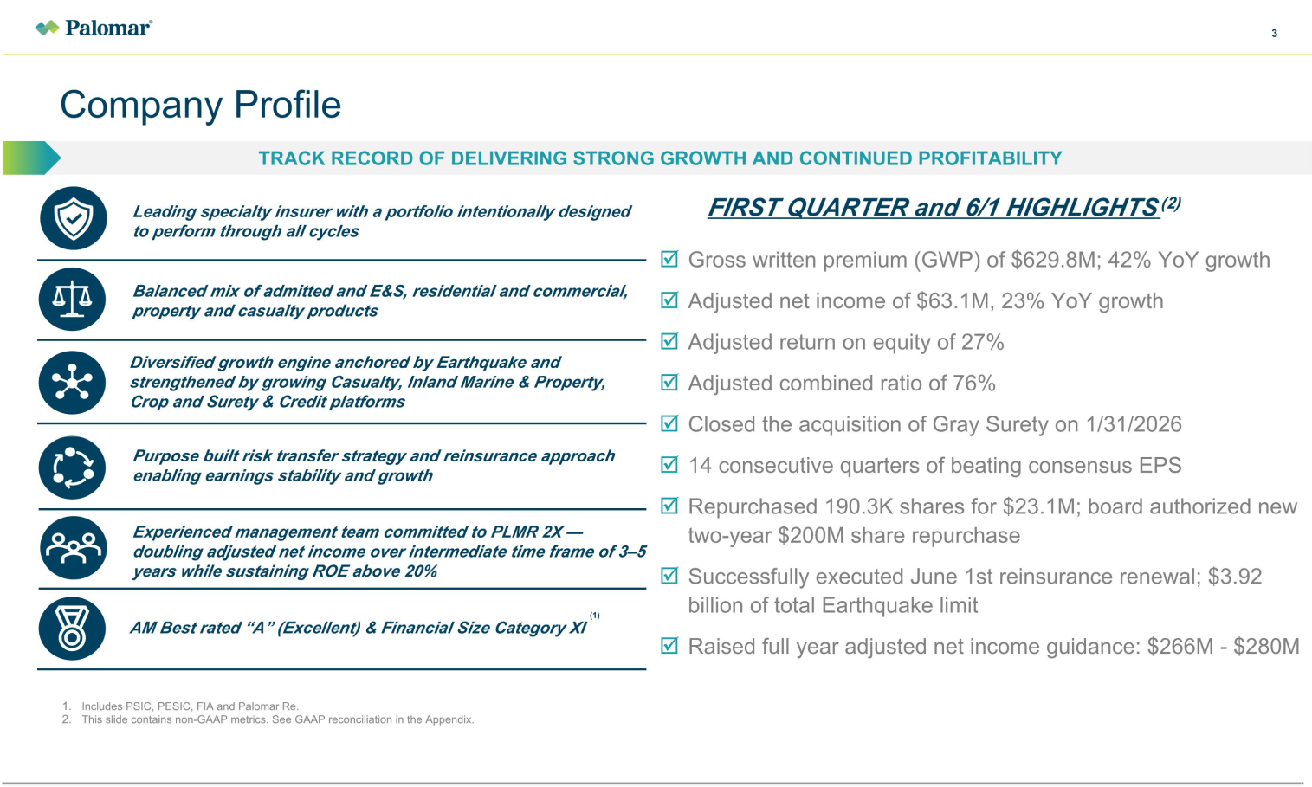

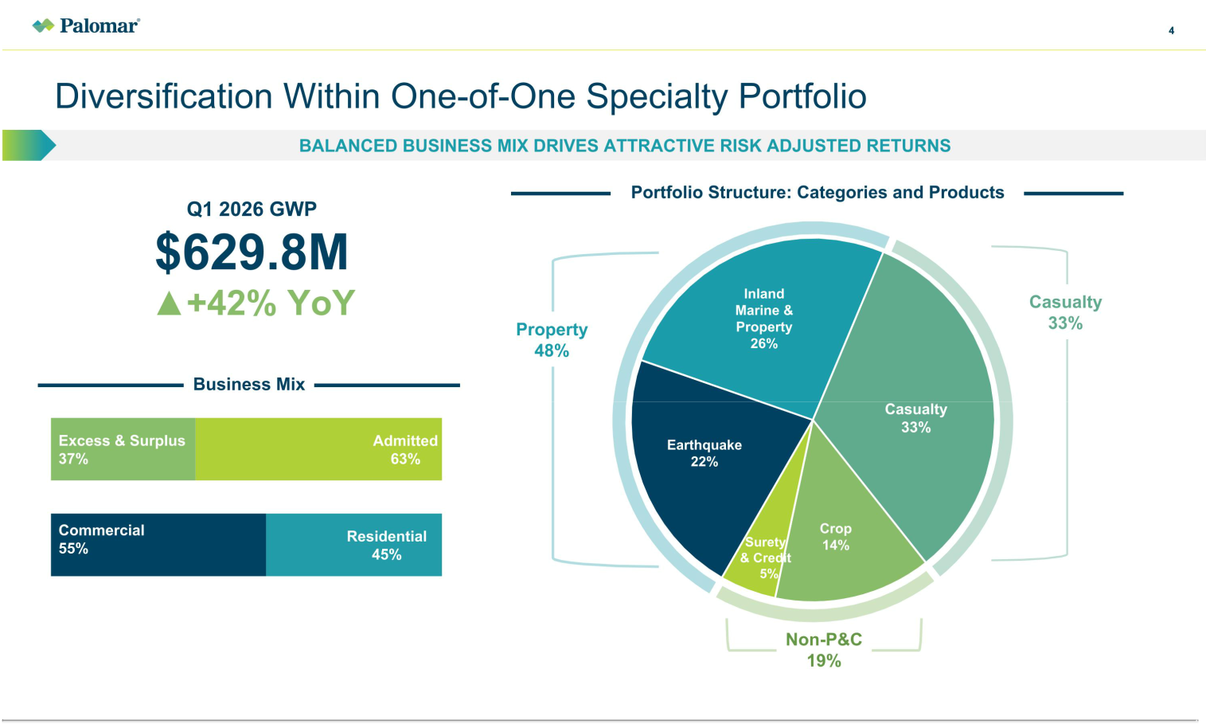

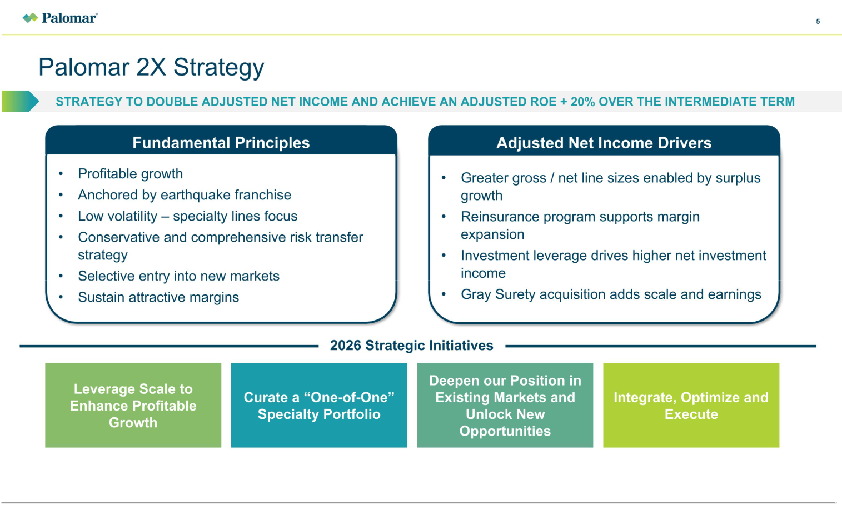

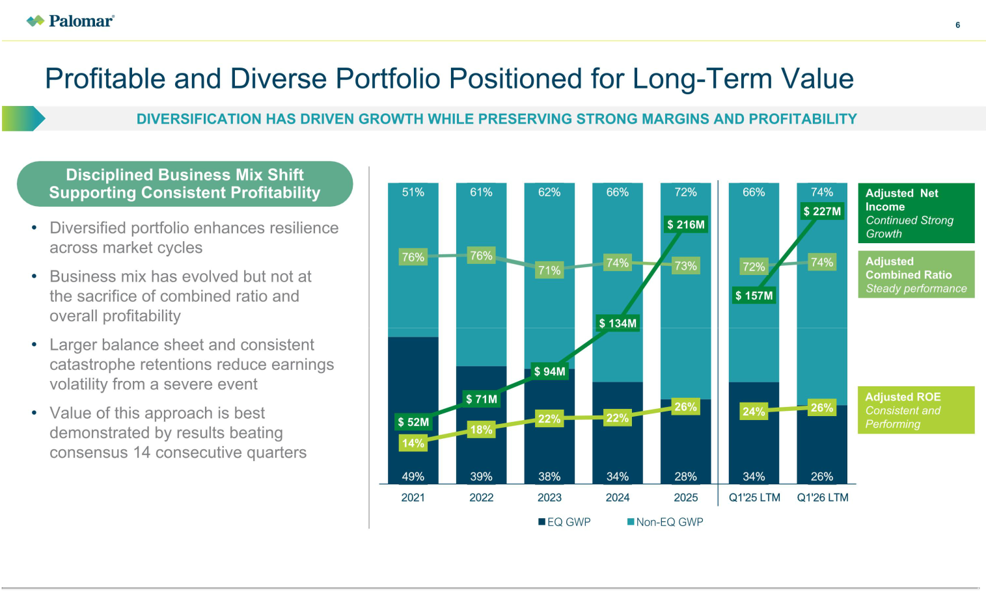

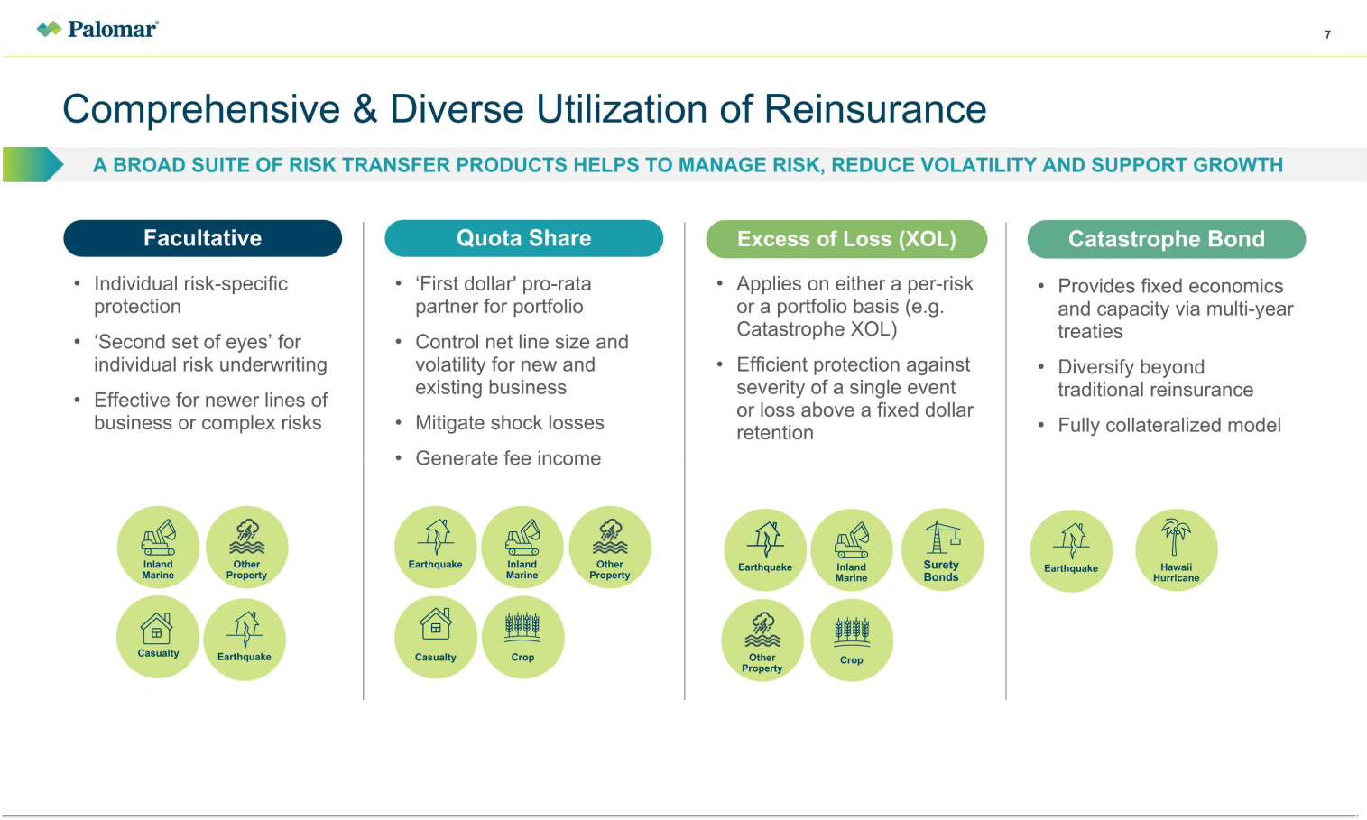

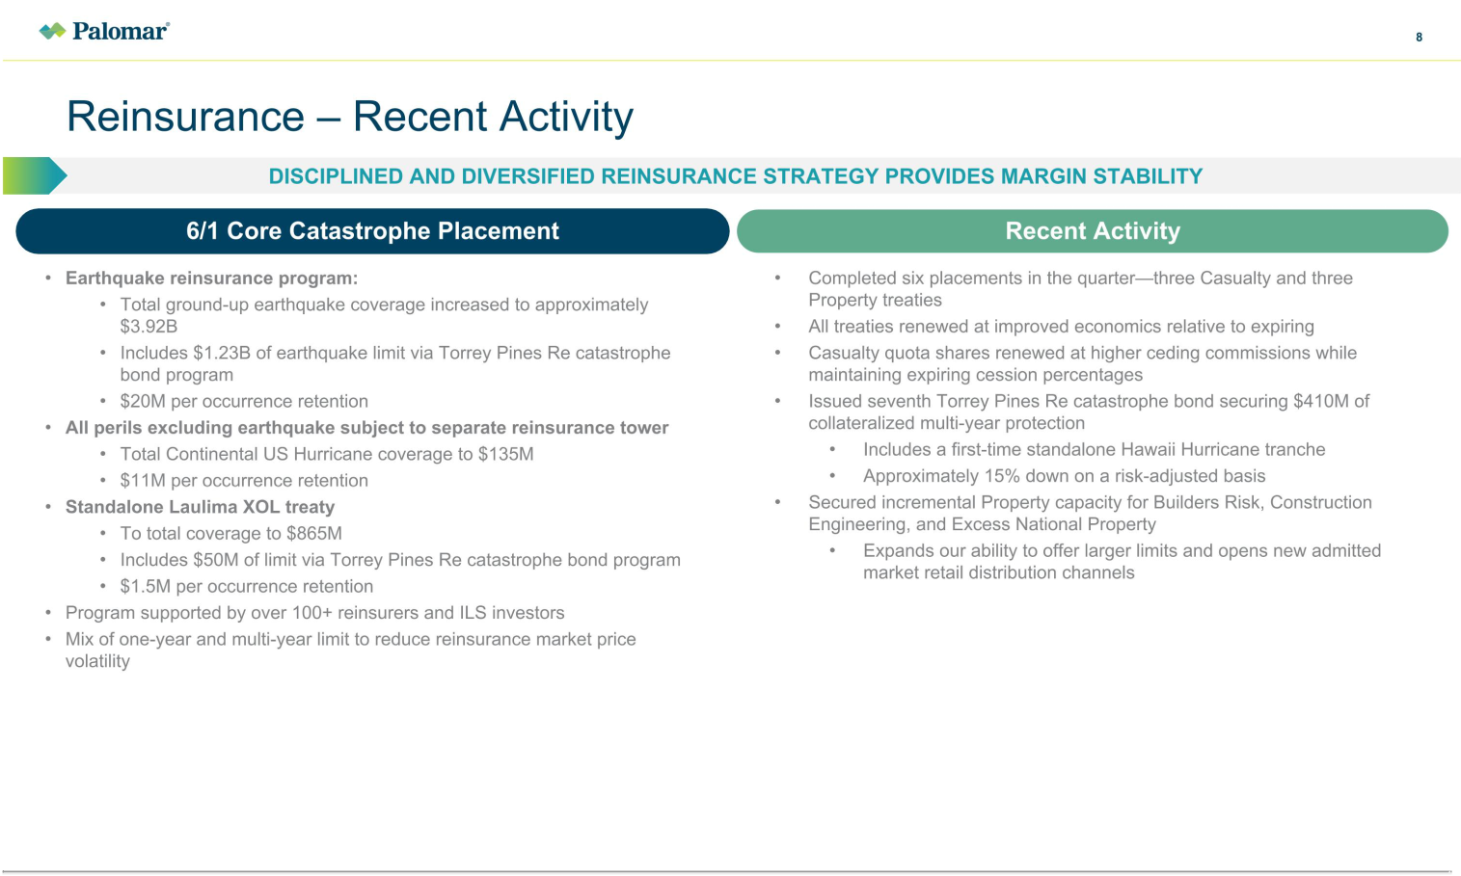

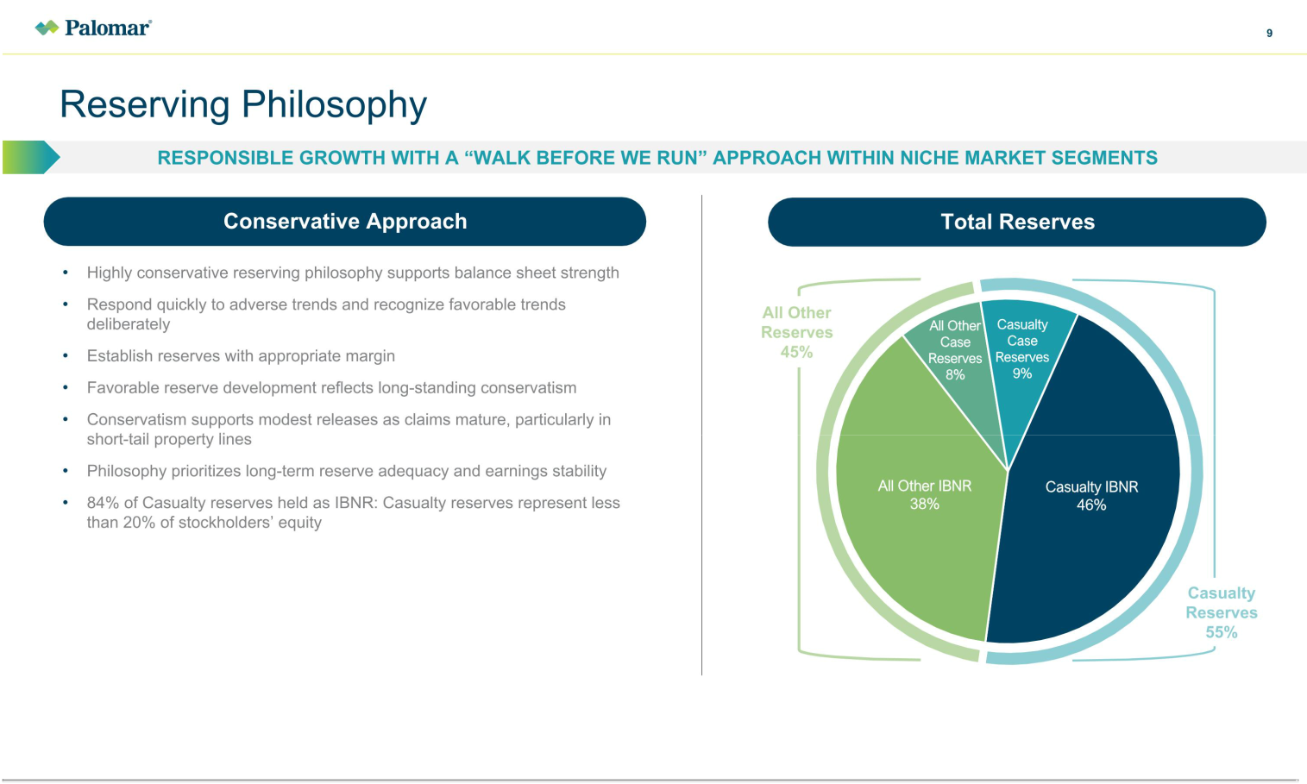

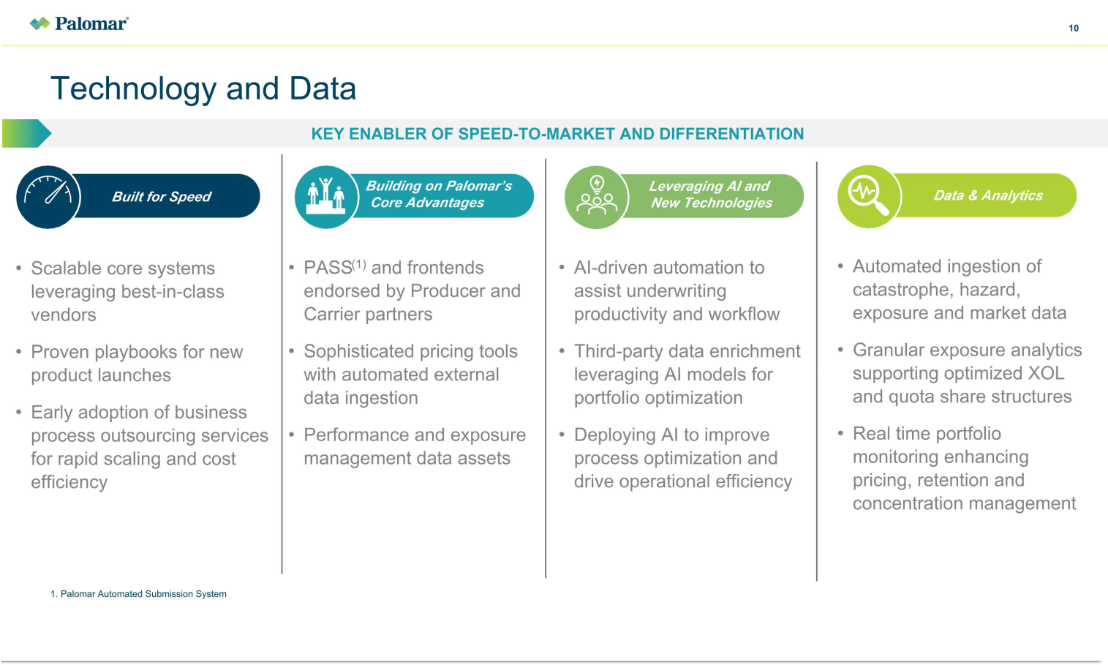

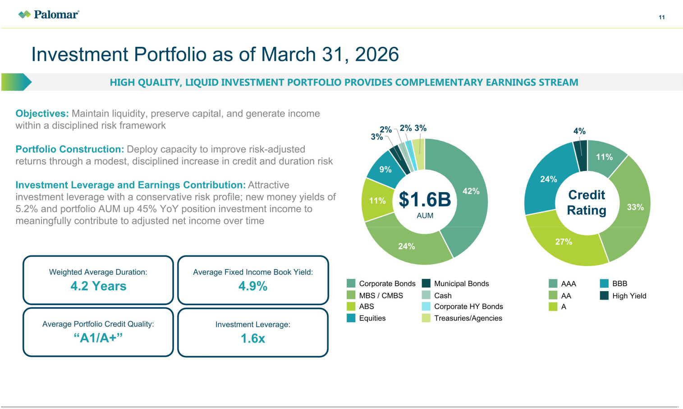

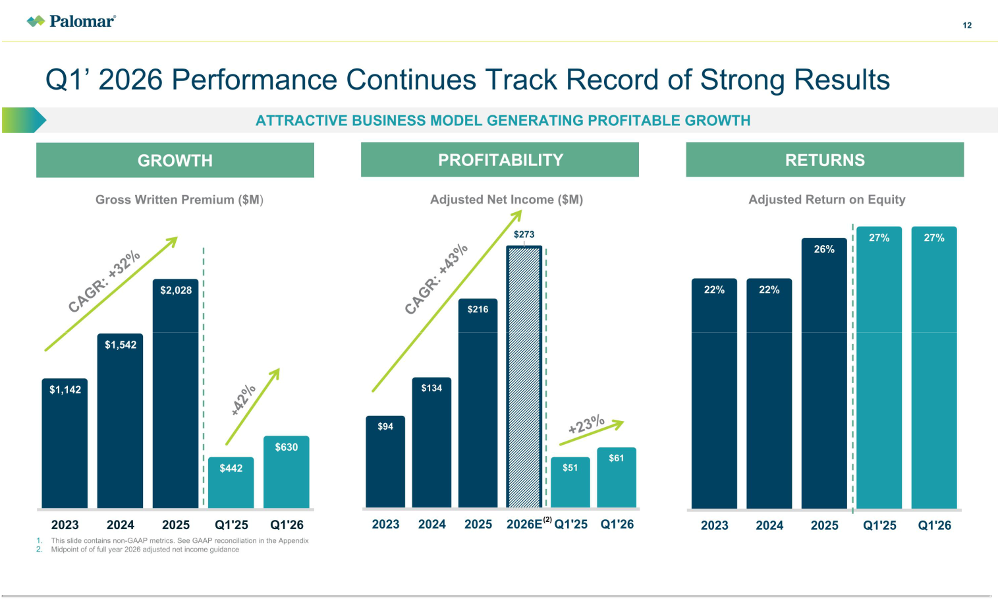

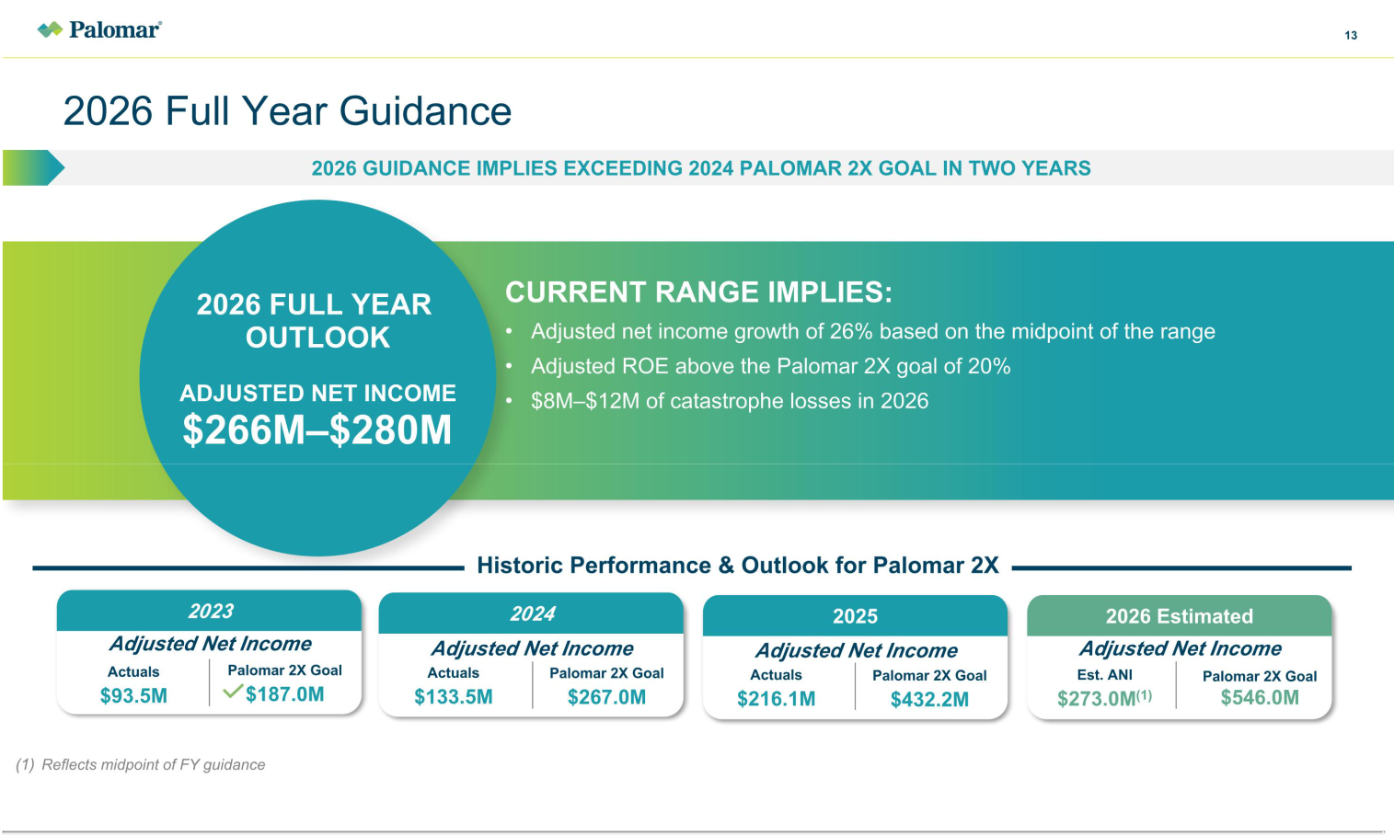

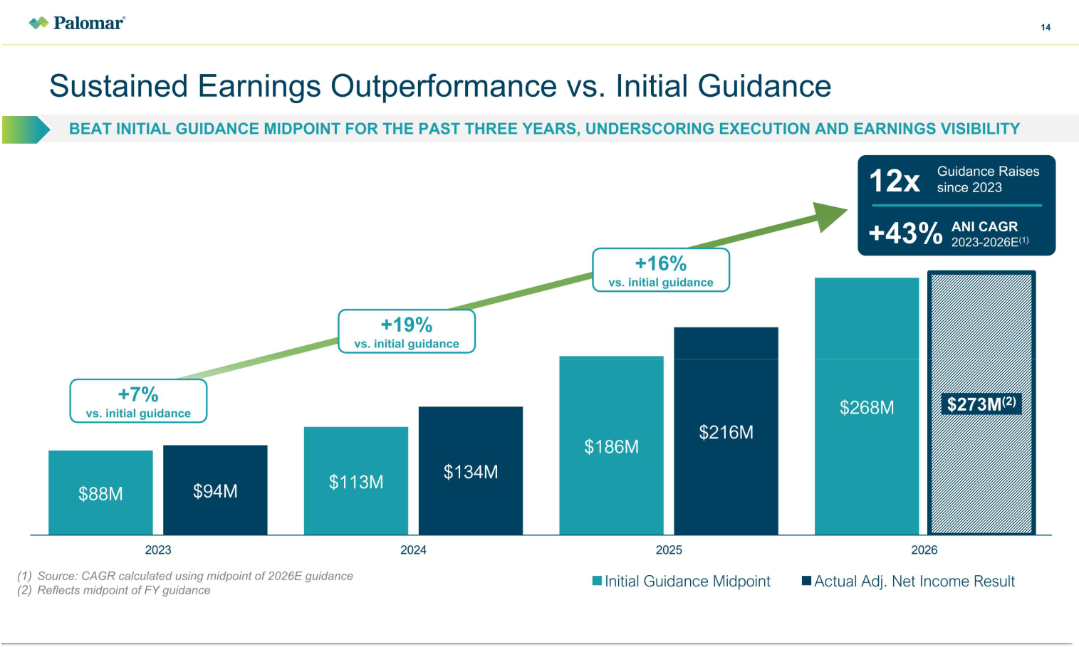

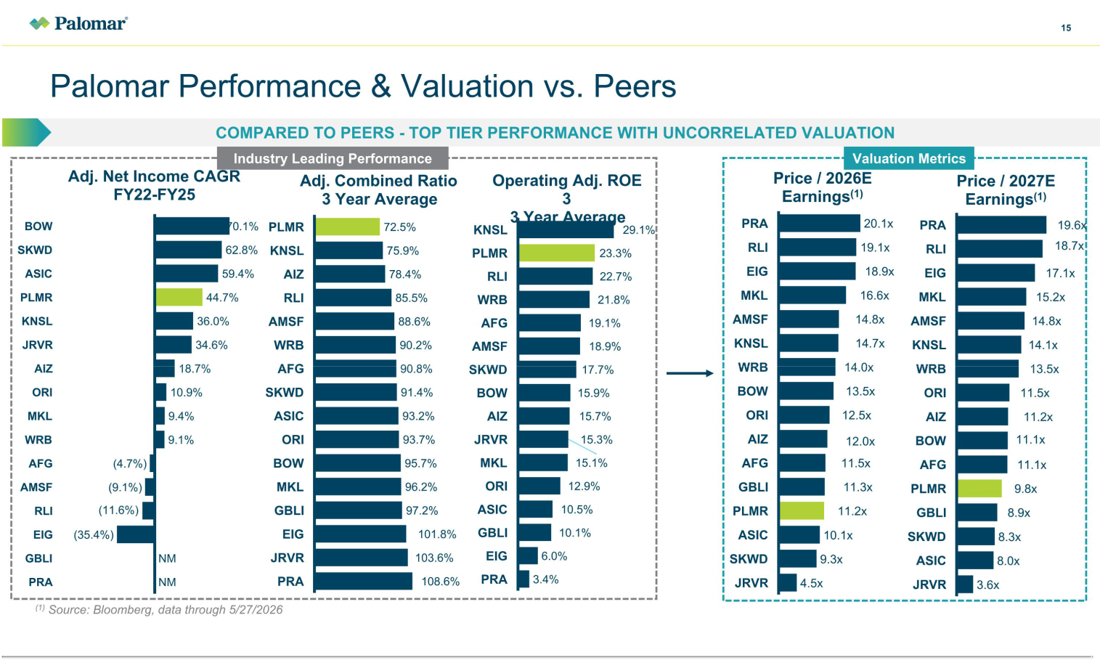





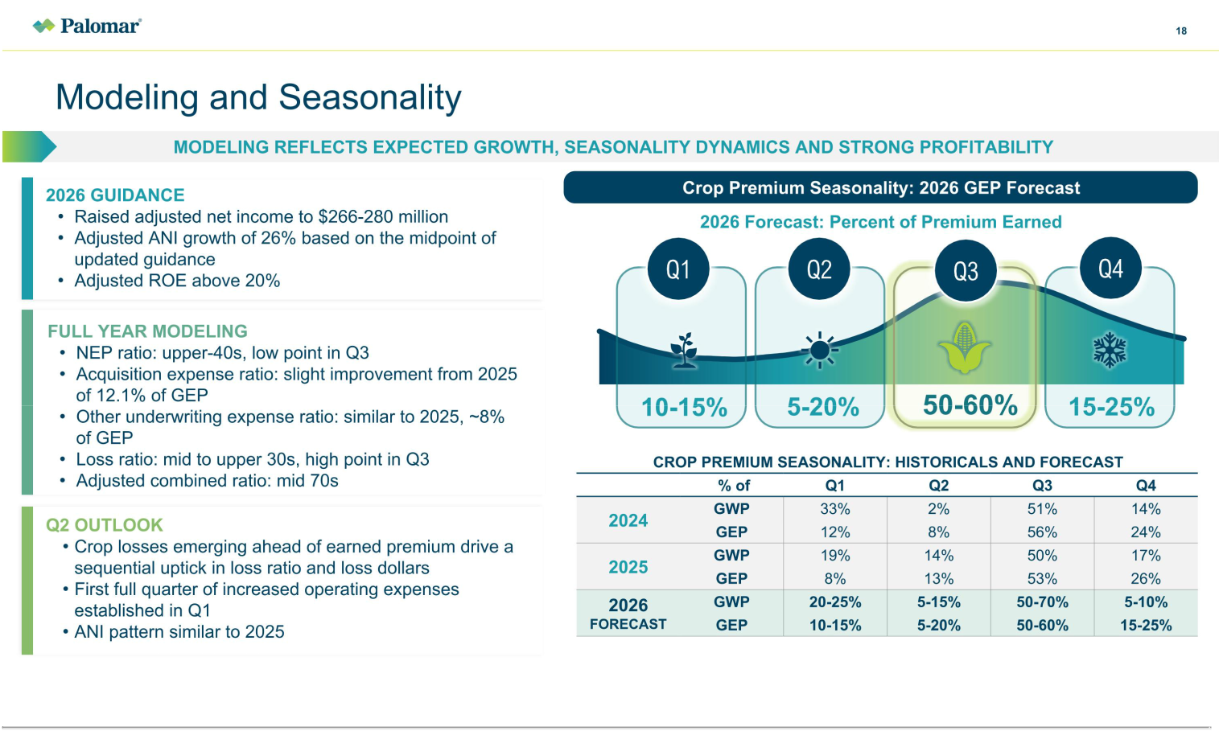

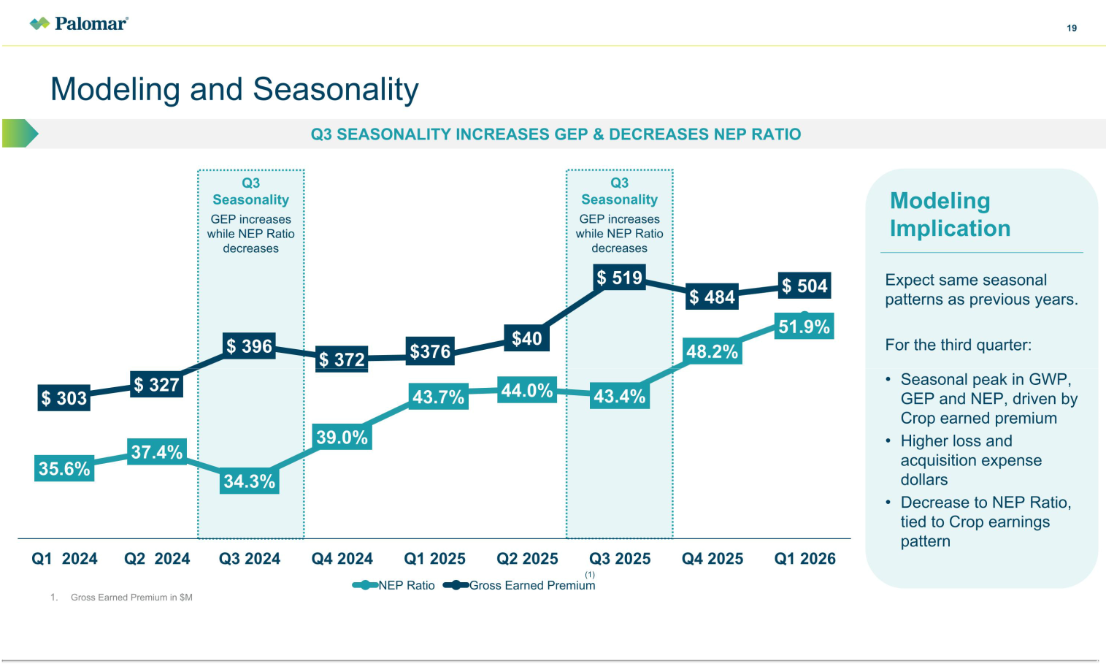

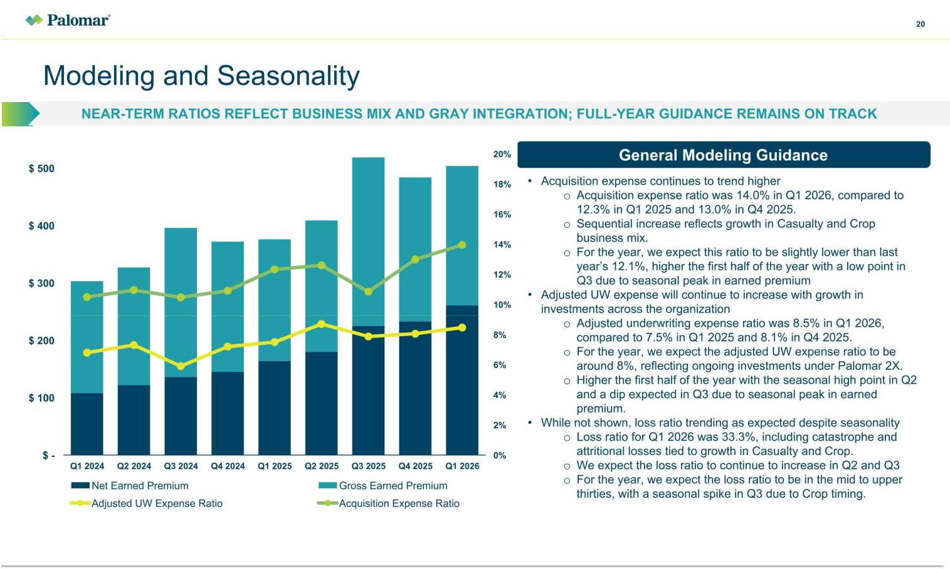

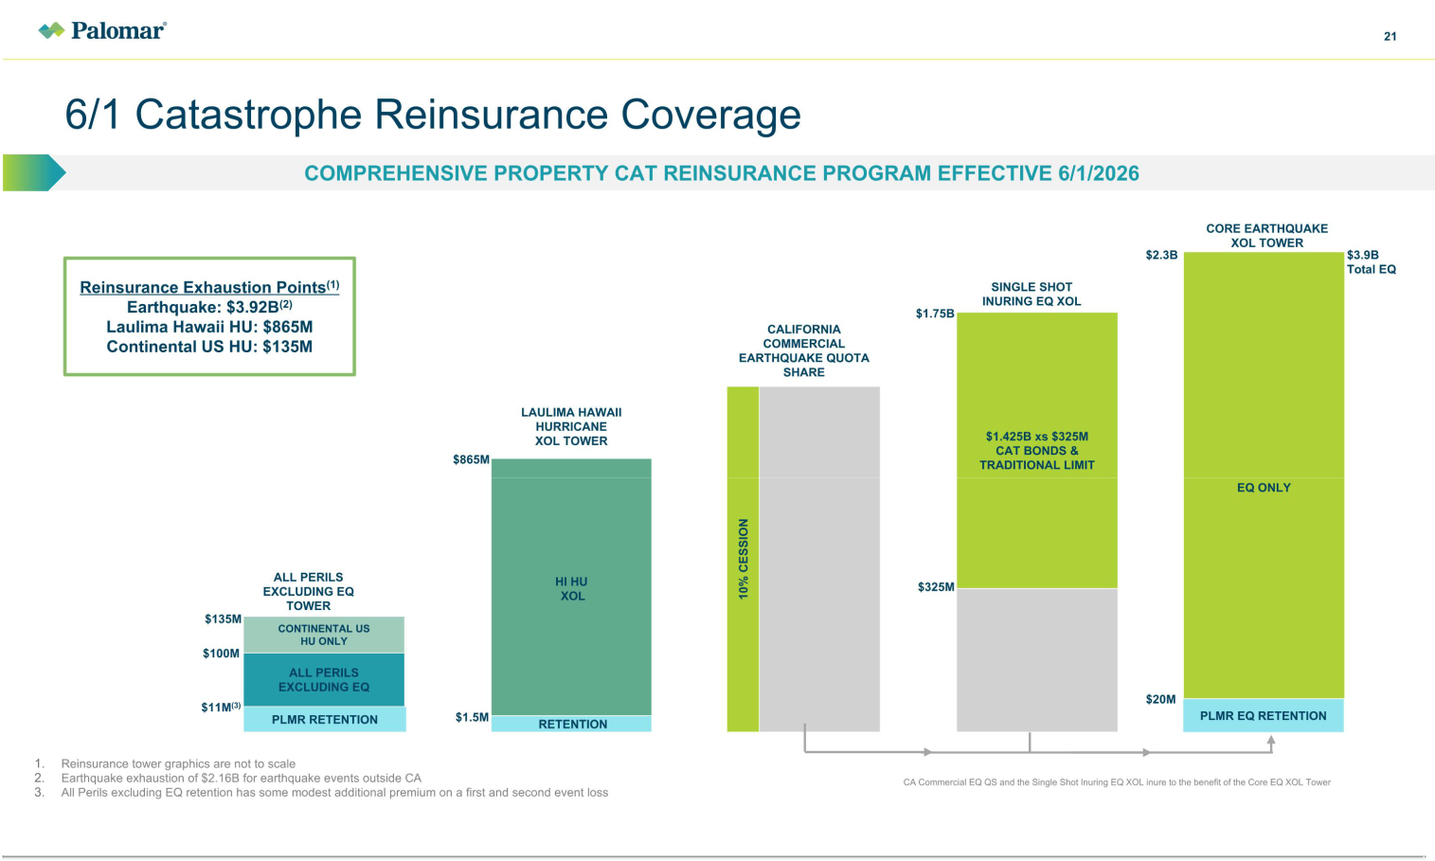

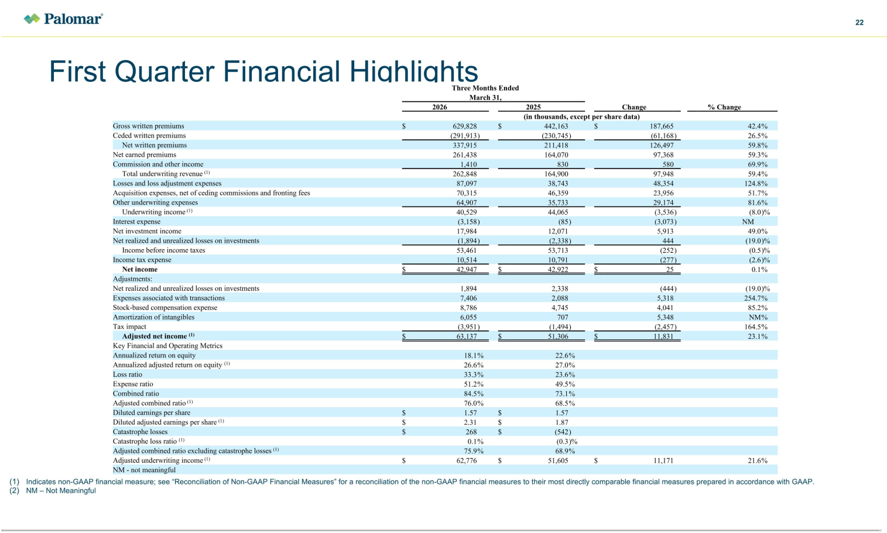

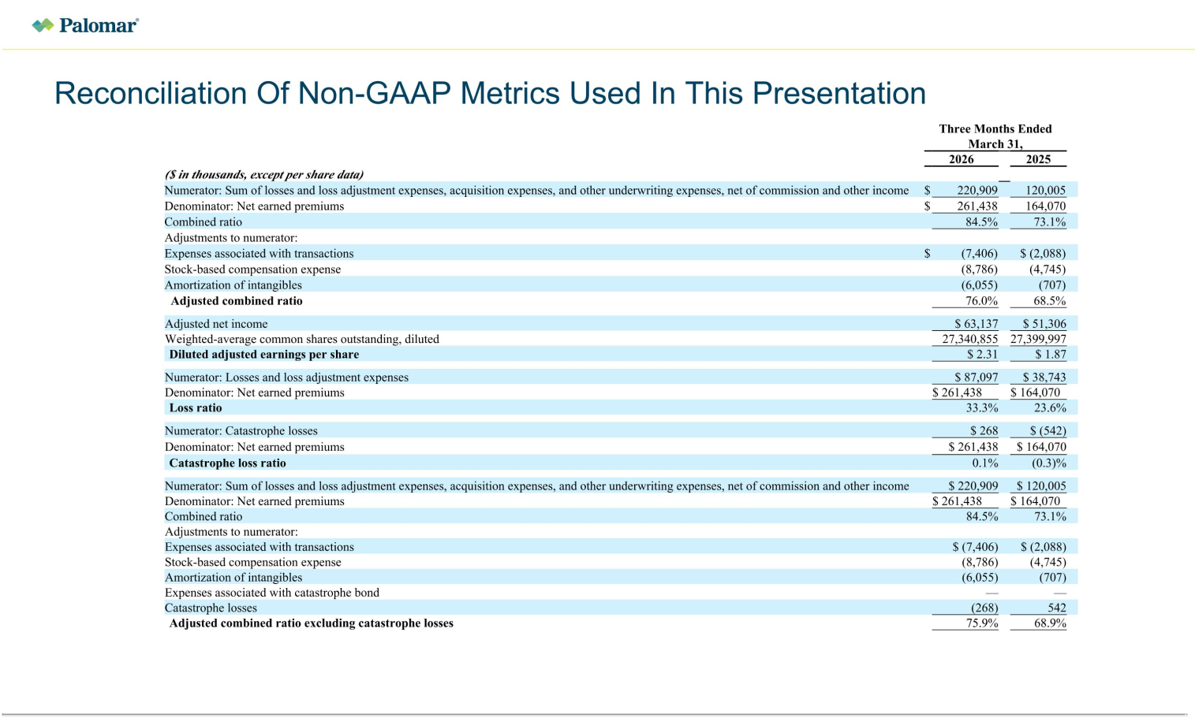

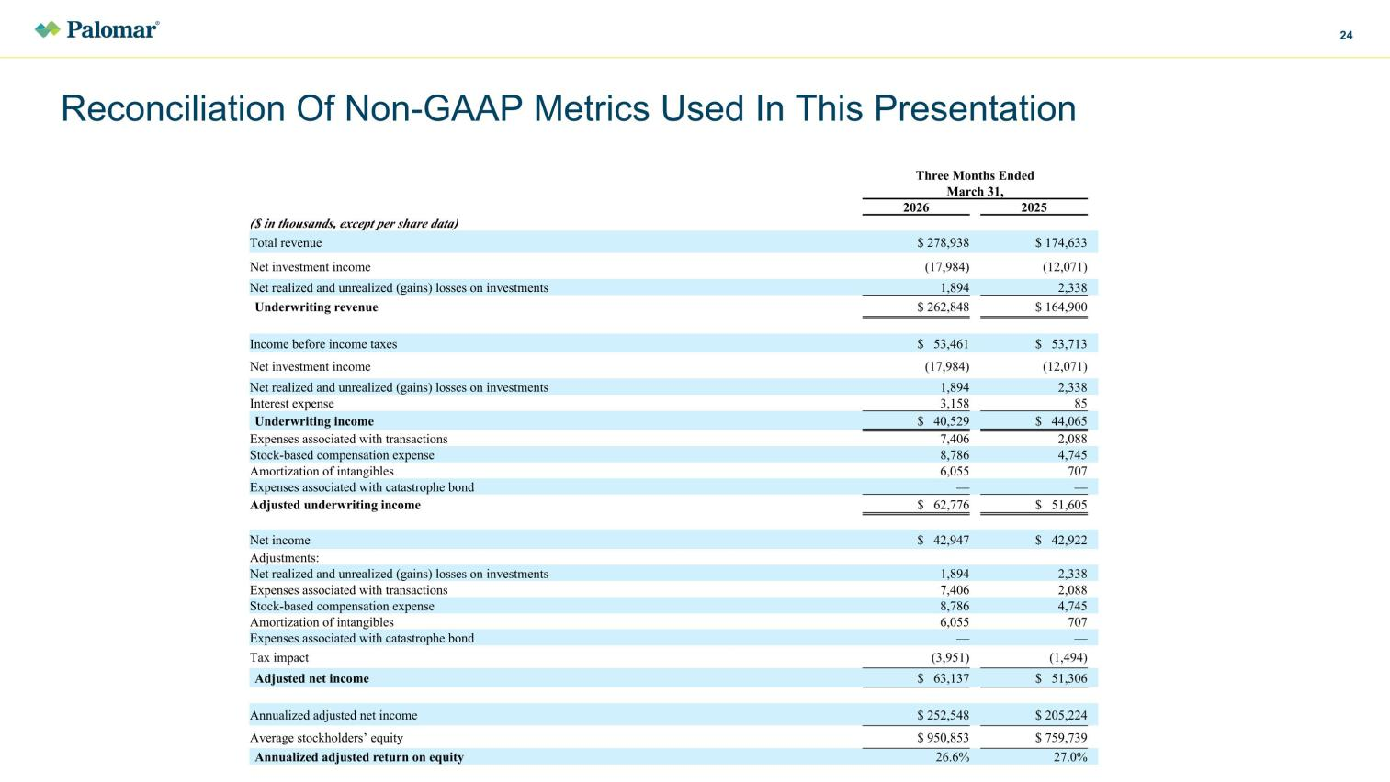

Ex 99.2


Palomar Holdings, Inc. Announces Successful Completion of June 1 Reinsurance Placement ~ Full Year 2026 Adjusted Net Income Guidance Increased to $266 Million to $280 Million ~

LA JOLLA, Calif., May 29, 2026 (GLOBE NEWSWIRE) -- Palomar Holdings, Inc. (NASDAQ: PLMR) (“Palomar” or the “Company”) today announced the successful completion of certain reinsurance programs incepting June 1, 2026, and increased the Company’s full year 2026 adjusted net income guidance.

The Company has procured approximately $421 million of incremental limit to support the growth of its Earthquake franchise. Palomar’s reinsurance coverage now extends to $3.92 billion for earthquake events and $135 million for continental United States hurricane events.

Palomar’s per occurrence event retentions will remain at $11 million for hurricane events and $20 million for earthquake events, levels that are meaningfully within management’s previously stated guideposts of less than one quarter’s adjusted net income and less than 5% of stockholders’ equity.

The reinsurance program continues to provide ample capacity for the Company’s growth in the subject business lines as well as coverage to a level exceeding Palomar’s 1:250-year peak zone Probable Maximum Loss. Of note, $360 million of the $3.92 billion earthquake limit was sourced through Palomar’s seventh Torrey Pines Re catastrophe bond issuance, priced at the lower end of the indicated range.

Palomar also renewed its standalone reinsurance treaty supporting the Hawaii hurricane policies issued by Laulima Exchange. The renewed program provides Laulima with up to $865 million of per-occurrence coverage, representing a $130 million increase year-over-year, including $50 million sourced through the Torrey Pines Re platform. The placement marked the first inclusion of a standalone Hawaii Hurricane tranche within Torrey Pines Re, further diversifying Palomar’s sources of reinsurance capacity. The program’s per-occurrence event retention remained unchanged at $1.5 million.

“We are very pleased with the outcome of our June 1 reinsurance placement and remain grateful for the support of our broad and diversified reinsurance panel,” commented Mac Armstrong, Chairman and Chief Executive Officer of Palomar. “We added meaningful incremental limit to support growth, maintain event retentions at levels consistent with the expiring treaty despite significant earnings and exposure growth, and expanding the role of collateralized reinsurance through another Torrey Pines Re catastrophe bond issuance. Importantly, we achieved these objectives at attractive economics which well-positions Palomar to deliver profitable growth and attractive returns for shareholders. As a result, we are increasing our full-year 2026 adjusted net income guidance range to $266 million to $280 million from the previously indicated range of $262 million to $278 million.”

Other highlights of the Company’s reinsurance program include:

- Issued seventh Torrey Pines Re catastrophe bond securing $410M of protection, a total of $1.28 billion of multi-year ILS capacity providing diversifying collateralized reinsurance capital;

- A reinsurance panel of over 100 reinsurers and ILS investors, including multiple new reinsurers, all of which have an “A-” (Excellent) or better financial strength rating from A.M. Best and/or S&P (Standard & Poor’s) or are fully collateralized;

- Prepaid reinstatements across substantially all layers that have a reinstatement provision with only modest additional reinsurance premium due in certain multiple event scenarios.

Palomar’s Chief Risk Officer, Jon Knutzen, added, “This June 1 renewal further strengthens Palomar’s ability to manage peak catastrophe volatility while supporting continued profitable growth. The combination of incremental limit for our peak peril zones and expanded ILS capacity improves both the efficiency and diversification of our overall reinsurance program. We appreciate the continued support from our global reinsurance partners and believe this placement positions the Company favorably from both a capital management and earnings stability perspective.”

About Palomar Holdings, Inc.

Palomar Holdings, Inc. is the holding company of subsidiaries Palomar Specialty Insurance Company (“PSIC”), Palomar Specialty Reinsurance Company Bermuda Ltd. (“PSRE”), Palomar Insurance Agency, Inc., Palomar Excess and Surplus Insurance Company (“PESIC”), Palomar Underwriters Exchange Organization, Inc. (“PUEO”), First Indemnity of America Insurance Co. (“FIA”), Palomar Crop Insurance Services, Inc. (“PCIS”), and Palomar Casualty and Surety Company (“PCSC”). Palomar’s consolidated results also include Laulima Exchange (“Laulima”), a variable interest entity for which the Company is the primary beneficiary. Palomar is an innovative specialty insurer serving residential and commercial clients in five product categories: Earthquake, Inland Marine and Property, Casualty, Surety & Credit, and Crop. Palomar’s insurance subsidiaries, PSIC, PSRE, PESIC, and FIA have a financial strength rating of “A” (Excellent) from A.M. Best and PCSC has a financial strength rating of “A-” (Excellent) from A.M. Best.

To learn more, visit PLMR.com.

Follow Palomar on LinkedIn: @PLMRInsurance

Safe Harbor Statement

Palomar cautions you that statements contained in this press release may regard matters that are not historical facts but are forward-looking statements. These statements are based on the company’s current beliefs and expectations. The inclusion of forward-looking statements should not be regarded as a representation by Palomar that any of its plans will be achieved. Actual results may differ from those set forth in this press release due to the risks and uncertainties inherent in the Company’s business. The forward-looking statements are typically, but not always, identified through use of the words "believe," "expect," "enable," "may," "will," "could," "intends," "estimate," "anticipate," "plan," "predict,"

"probable," "potential," "possible," "should," "continue," and other words of similar meaning. Actual results could differ materially from the expectations contained in forward-looking statements as a result of several factors, including unexpected expenditures and costs, unexpected results or delays in development and regulatory review, regulatory approval requirements, the frequency and severity of adverse events and competitive conditions. These and other factors that may result in differences are discussed in greater detail in the Company's filings with the Securities and Exchange Commission. You are cautioned not to place undue reliance on these forward-looking statements, which speak only as of the date hereof, and the Company undertakes no obligation to update such statements to reflect events that occur or circumstances that exist after the date hereof. All forward-looking statements are qualified in their entirety by this cautionary statement, which is made under the safe harbor provisions of the Private Securities Litigation Reform Act of 1995.

Contact

Media Inquiries
Lindsay Conner
1-551-206-6217

lconner@plmr.com

Investor Relations

Jamie Lillis
1-203-428-3223
investors@plmr.com

Source: Palomar Holdings, Inc.

