UNITED STATES
SECURITIES AND EXCHANGE COMMISSION
WASHINGTON, D.C. 20549

FORM 8-K

CURRENT REPORT
Pursuant to Section 13 or 15(d) of the Securities Exchange Act of 1934
Date of Report (Date of earliest event reported): August 10, 2026

Palomar Holdings, Inc.
(Exact name of Registrant as Specified in Its Charter)

Delaware |  |  | 001-38873 | 83-3972551
(State or Other Jurisdiction  of Incorporation) |  |  | (Commission File Number) | (IRS Employer  Identification No.)
7979 Ivanhoe Avenue, Suite 500
La Jolla, California |  |  |  | 92037
(Address of Principal Executive Offices) |  |  |  | (Zip Code)

Registrant’s Telephone Number, Including Area Code: 619 567-5290

(Former Name or Former Address, if Changed Since Last Report)

Check the appropriate box below if the Form 8-K filing is intended to simultaneously satisfy the filing obligation of the registrant under any of the following provisions:
☐Written communications pursuant to Rule 425 under the Securities Act (17 CFR 230.425)
☐Soliciting material pursuant to Rule 14a-12 under the Exchange Act (17 CFR 240.14a-12)
☐Pre-commencement communications pursuant to Rule 14d-2(b) under the Exchange Act (17 CFR 240.14d-2(b))
☐Pre-commencement communications pursuant to Rule 13e-4(c) under the Exchange Act (17 CFR 240.13e-4(c))
Securities registered pursuant to Section 12(b) of the Act:
Title of each class |  | Trading  Symbol(s) |  | Name of each exchange on which registered
Common Stock, par value $0.0001 per share |  | PLMR |  | The Nasdaq Stock Market LLC
Indicate by check mark whether the registrant is an emerging growth company as defined in Rule 405 of the Securities Act of 1933 (§ 230.405 of this chapter) or Rule 12b-2 of the Securities Exchange Act of 1934 (§ 240.12b-2 of this chapter).
Emerging growth company ☐
If an emerging growth company, indicate by check mark if the registrant has elected not to use the extended transition period for complying with any new or revised financial accounting standards provided pursuant to Section 13(a) of the Exchange Act. ☐

Item 7.01 Regulation FD Disclosure.
On August 10, 2026, Palomar Holdings, Inc. (the “Company”) updated its corporate presentation that it uses for presentations at conferences and to analysts, current stockholders, and others. A copy of the Company’s presentation that it intends to use at such events is attached as Exhibit 99.1 and incorporated herein by reference.

Item 9.01 Financial Statements and Exhibits.
(d) | Exhibits.
Exhibit  Number | Description
99.1 | Investor Presentation, dated August 10, 2026
104 | Cover Page Interactive Data File (embedded within the Inline XBRL document)

SIGNATURES
Pursuant to the requirements of the Securities Exchange Act of 1934, the registrant has duly caused this report to be signed on its behalf by the undersigned hereunto duly authorized.
 |  |  | PALOMAR HOLDINGS, INC.
Date: | August 10, 2026 | By: | /s/ T. Christopher Uchida
T. Christopher Uchida
Chief Financial Officer
(Principal Financial and Accounting Officer)


Investor Presentation August 2026

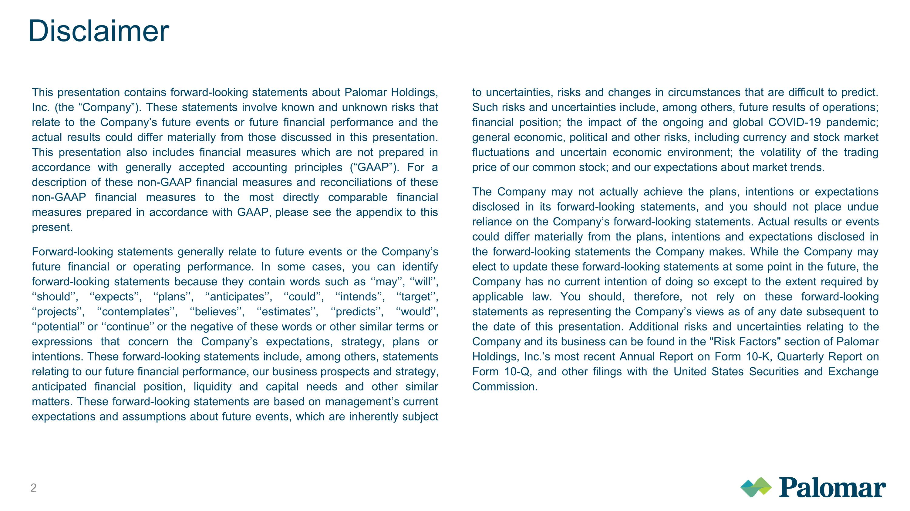
Disclaimer This presentation contains forward-looking statements about Palomar Holdings, Inc. (the “Company”). These statements involve known and unknown risks that relate to the Company’s future events or future financial performance and the actual results could differ materially from those discussed in this presentation. This presentation also includes financial measures which are not prepared in accordance with generally accepted accounting principles (“GAAP”). For a description of these non-GAAP financial measures and reconciliations of these non-GAAP financial measures to the most directly comparable financial measures prepared in accordance with GAAP, please see the appendix to this present. Forward-looking statements generally relate to future events or the Company’s future financial or operating performance. In some cases, you can identify forward-looking statements because they contain words such as ‘‘may’’, ‘‘will’’, ‘‘should’’, ‘‘expects’’, ‘‘plans’’, ‘‘anticipates’’, ‘‘could’’, ‘‘intends’’, ‘‘target’’, ‘‘projects’’, ‘‘contemplates’’, ‘‘believes’’, ‘‘estimates’’, ‘‘predicts’’, ‘‘would’’, ‘‘potential’’ or ‘‘continue’’ or the negative of these words or other similar terms or expressions that concern the Company’s expectations, strategy, plans or intentions. These forward-looking statements include, among others, statements relating to our future financial performance, our business prospects and strategy, anticipated financial position, liquidity and capital needs and other similar matters. These forward-looking statements are based on management’s current expectations and assumptions about future events, which are inherently subject to uncertainties, risks and changes in circumstances that are difficult to predict. Such risks and uncertainties include, among others, future results of operations; financial position; the impact of the ongoing and global COVID-19 pandemic; general economic, political and other risks, including currency and stock market fluctuations and uncertain economic environment; the volatility of the trading price of our common stock; and our expectations about market trends. The Company may not actually achieve the plans, intentions or expectations disclosed in its forward-looking statements, and you should not place undue reliance on the Company’s forward-looking statements. Actual results or events could differ materially from the plans, intentions and expectations disclosed in the forward-looking statements the Company makes. While the Company may elect to update these forward-looking statements at some point in the future, the Company has no current intention of doing so except to the extent required by applicable law. You should, therefore, not rely on these forward-looking statements as representing the Company’s views as of any date subsequent to the date of this presentation. Additional risks and uncertainties relating to the Company and its business can be found in the "Risk Factors" section of Palomar Holdings, Inc.’s most recent Annual Report on Form 10-K, Quarterly Report on Form 10-Q, and other filings with the United States Securities and Exchange Commission.

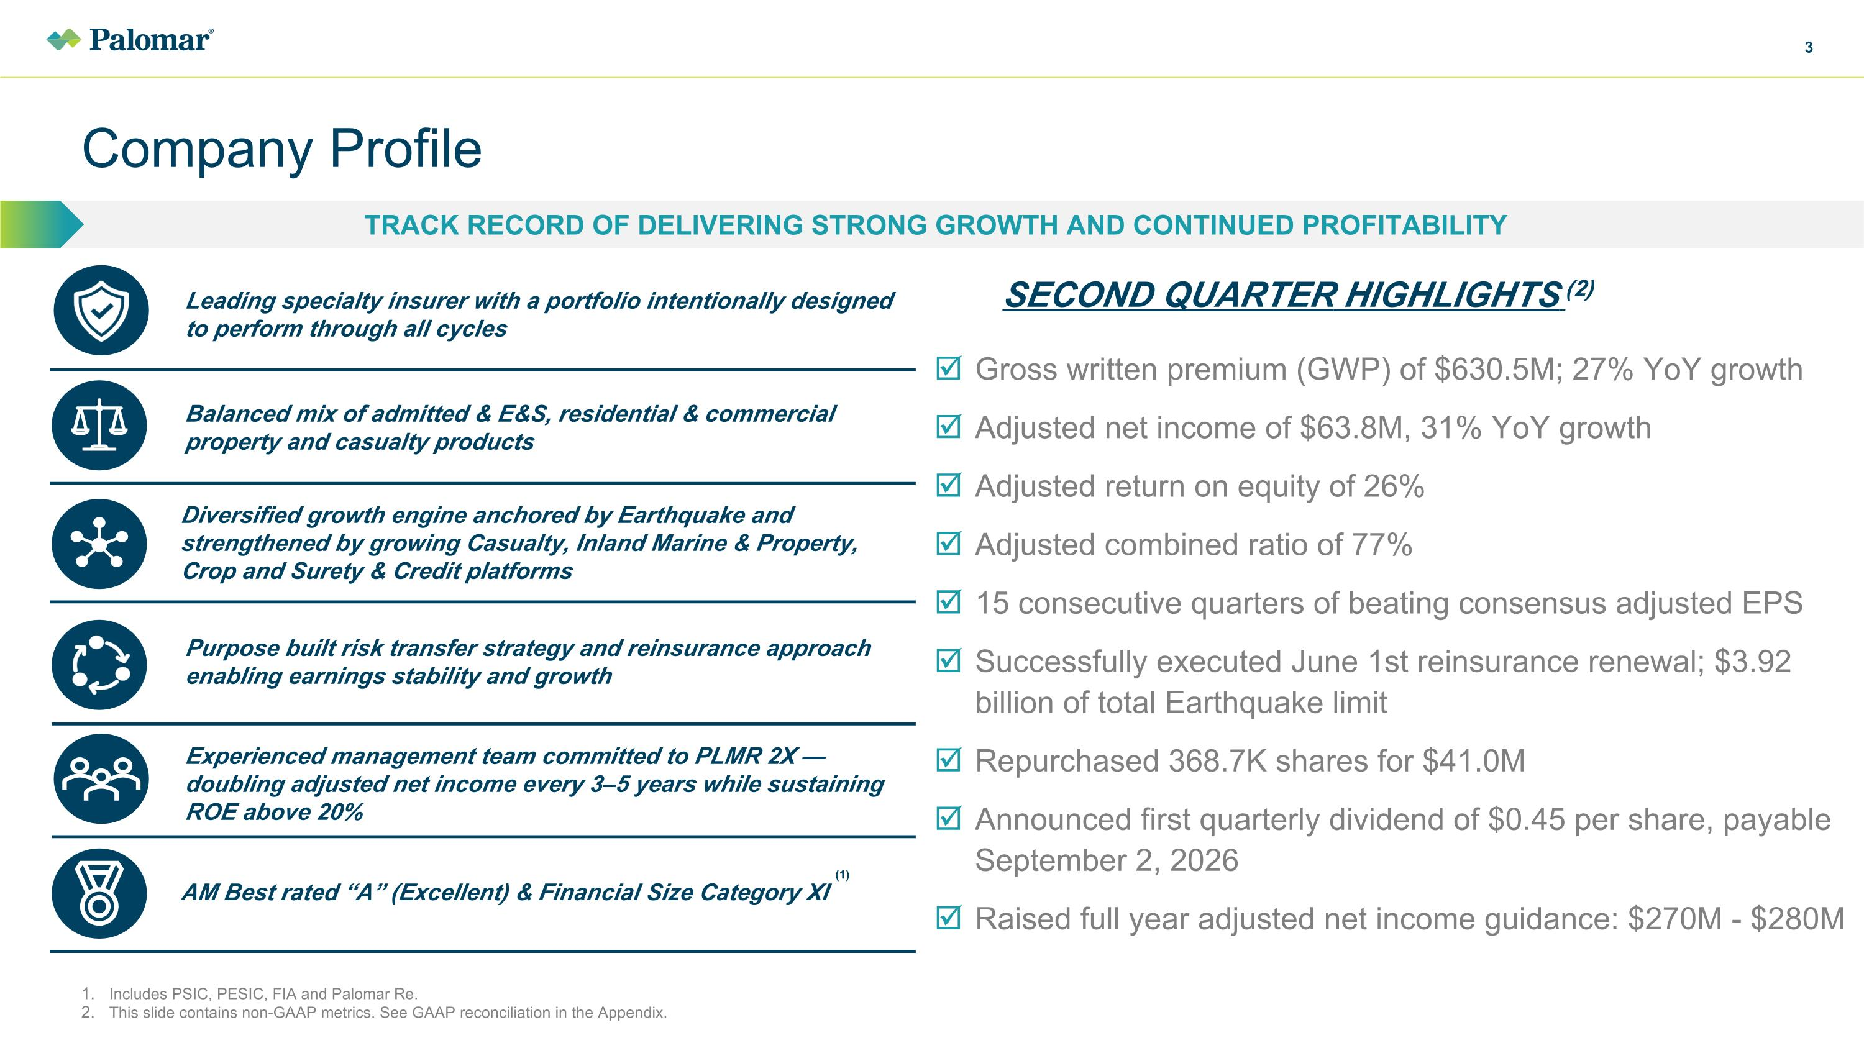
AM Best rated “A” (Excellent) & Financial Size Category XI Company Profile TRACK RECORD OF DELIVERING STRONG GROWTH AND CONTINUED PROFITABILITY Includes PSIC, PESIC, FIA and Palomar Re. This slide contains non-GAAP metrics. See GAAP reconciliation in the Appendix. SECOND QUARTER HIGHLIGHTS (2) Gross written premium (GWP) of $630.5M; 27% YoY growth Adjusted net income of $63.8M, 31% YoY growth Adjusted return on equity of 26% Adjusted combined ratio of 77% 15 consecutive quarters of beating consensus adjusted EPS Successfully executed June 1st reinsurance renewal; $3.92 billion of total Earthquake limit Repurchased 368.7K shares for $41.0M Announced first quarterly dividend of $0.45 per share, payable September 2, 2026 Raised full year adjusted net income guidance: $270M - $280M Balanced mix of admitted & E&S, residential & commercial property and casualty products Diversified growth engine anchored by Earthquake and strengthened by growing Casualty, Inland Marine & Property, Crop and Surety & Credit platforms Purpose built risk transfer strategy and reinsurance approach enabling earnings stability and growth Experienced management team committed to PLMR 2X — doubling adjusted net income every 3–5 years while sustaining ROE above 20% Leading specialty insurer with a portfolio intentionally designed to perform through all cycles (1)

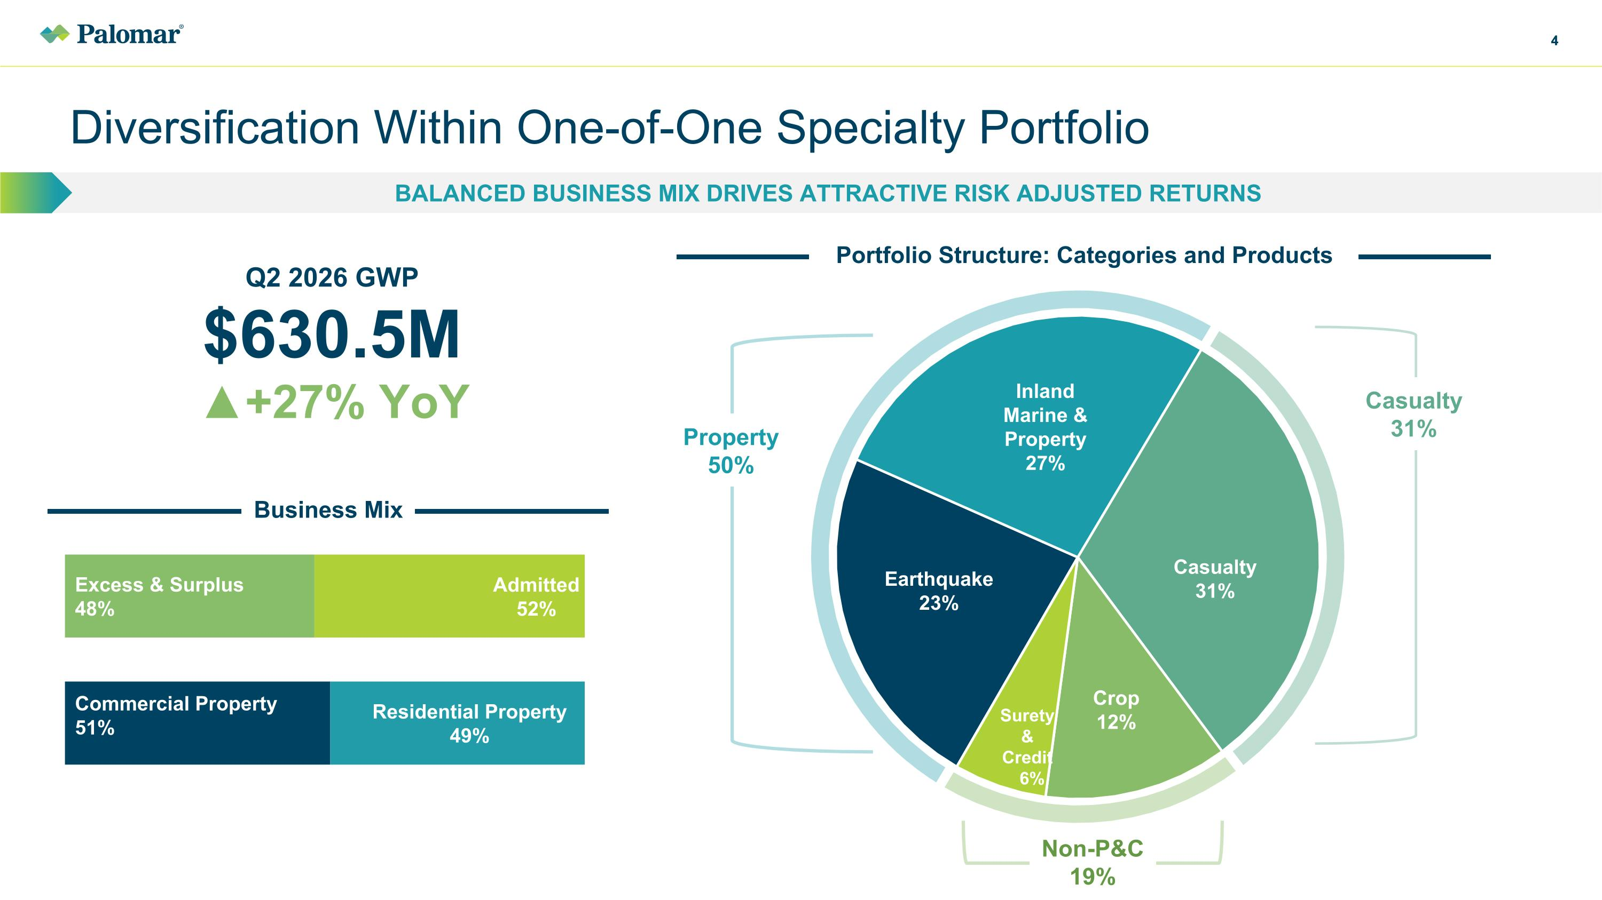
Diversification Within One-of-One Specialty Portfolio Balanced Business mix Drives attractive risk adjusted returns 4 Portfolio Structure: Categories and Products Non-P&C 19% Property 50% Casualty 31% Business Mix Q2 2026 GWP $630.5M ▲+27% YoY

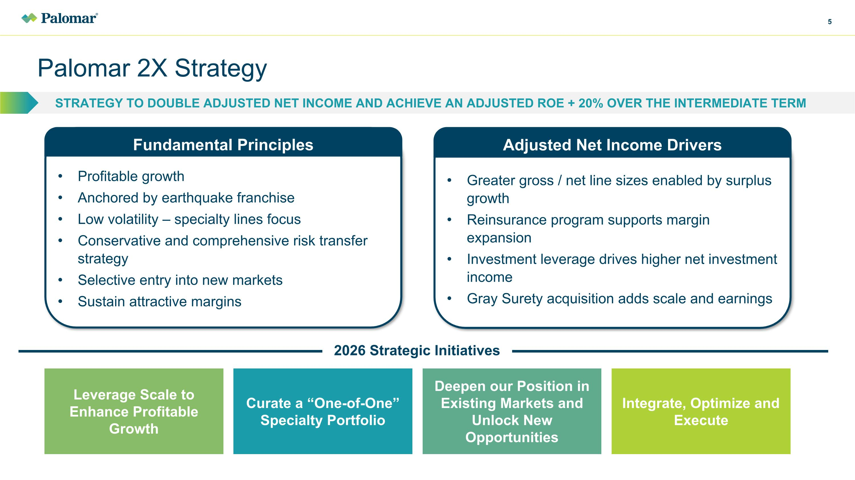
Palomar 2X Strategy STRATEGY TO DOUBLE ADJUSTED NET INCOME and ACHIEVE AN ADJUSTED ROE + 20% OVER THE INTERMEDIATE TERM Profitable growth Anchored by earthquake franchise Low volatility – specialty lines focus Conservative and comprehensive risk transfer strategy Selective entry into new markets Sustain attractive margins Fundamental Principles Greater gross / net line sizes enabled by surplus growth Reinsurance program supports margin expansion Investment leverage drives higher net investment income Gray Surety acquisition adds scale and earnings Adjusted Net Income Drivers Leverage Scale to Enhance Profitable Growth Curate a “One-of-One” Specialty Portfolio Deepen our Position in Existing Markets and Unlock New Opportunities Integrate, Optimize and Execute 2026 Strategic Initiatives

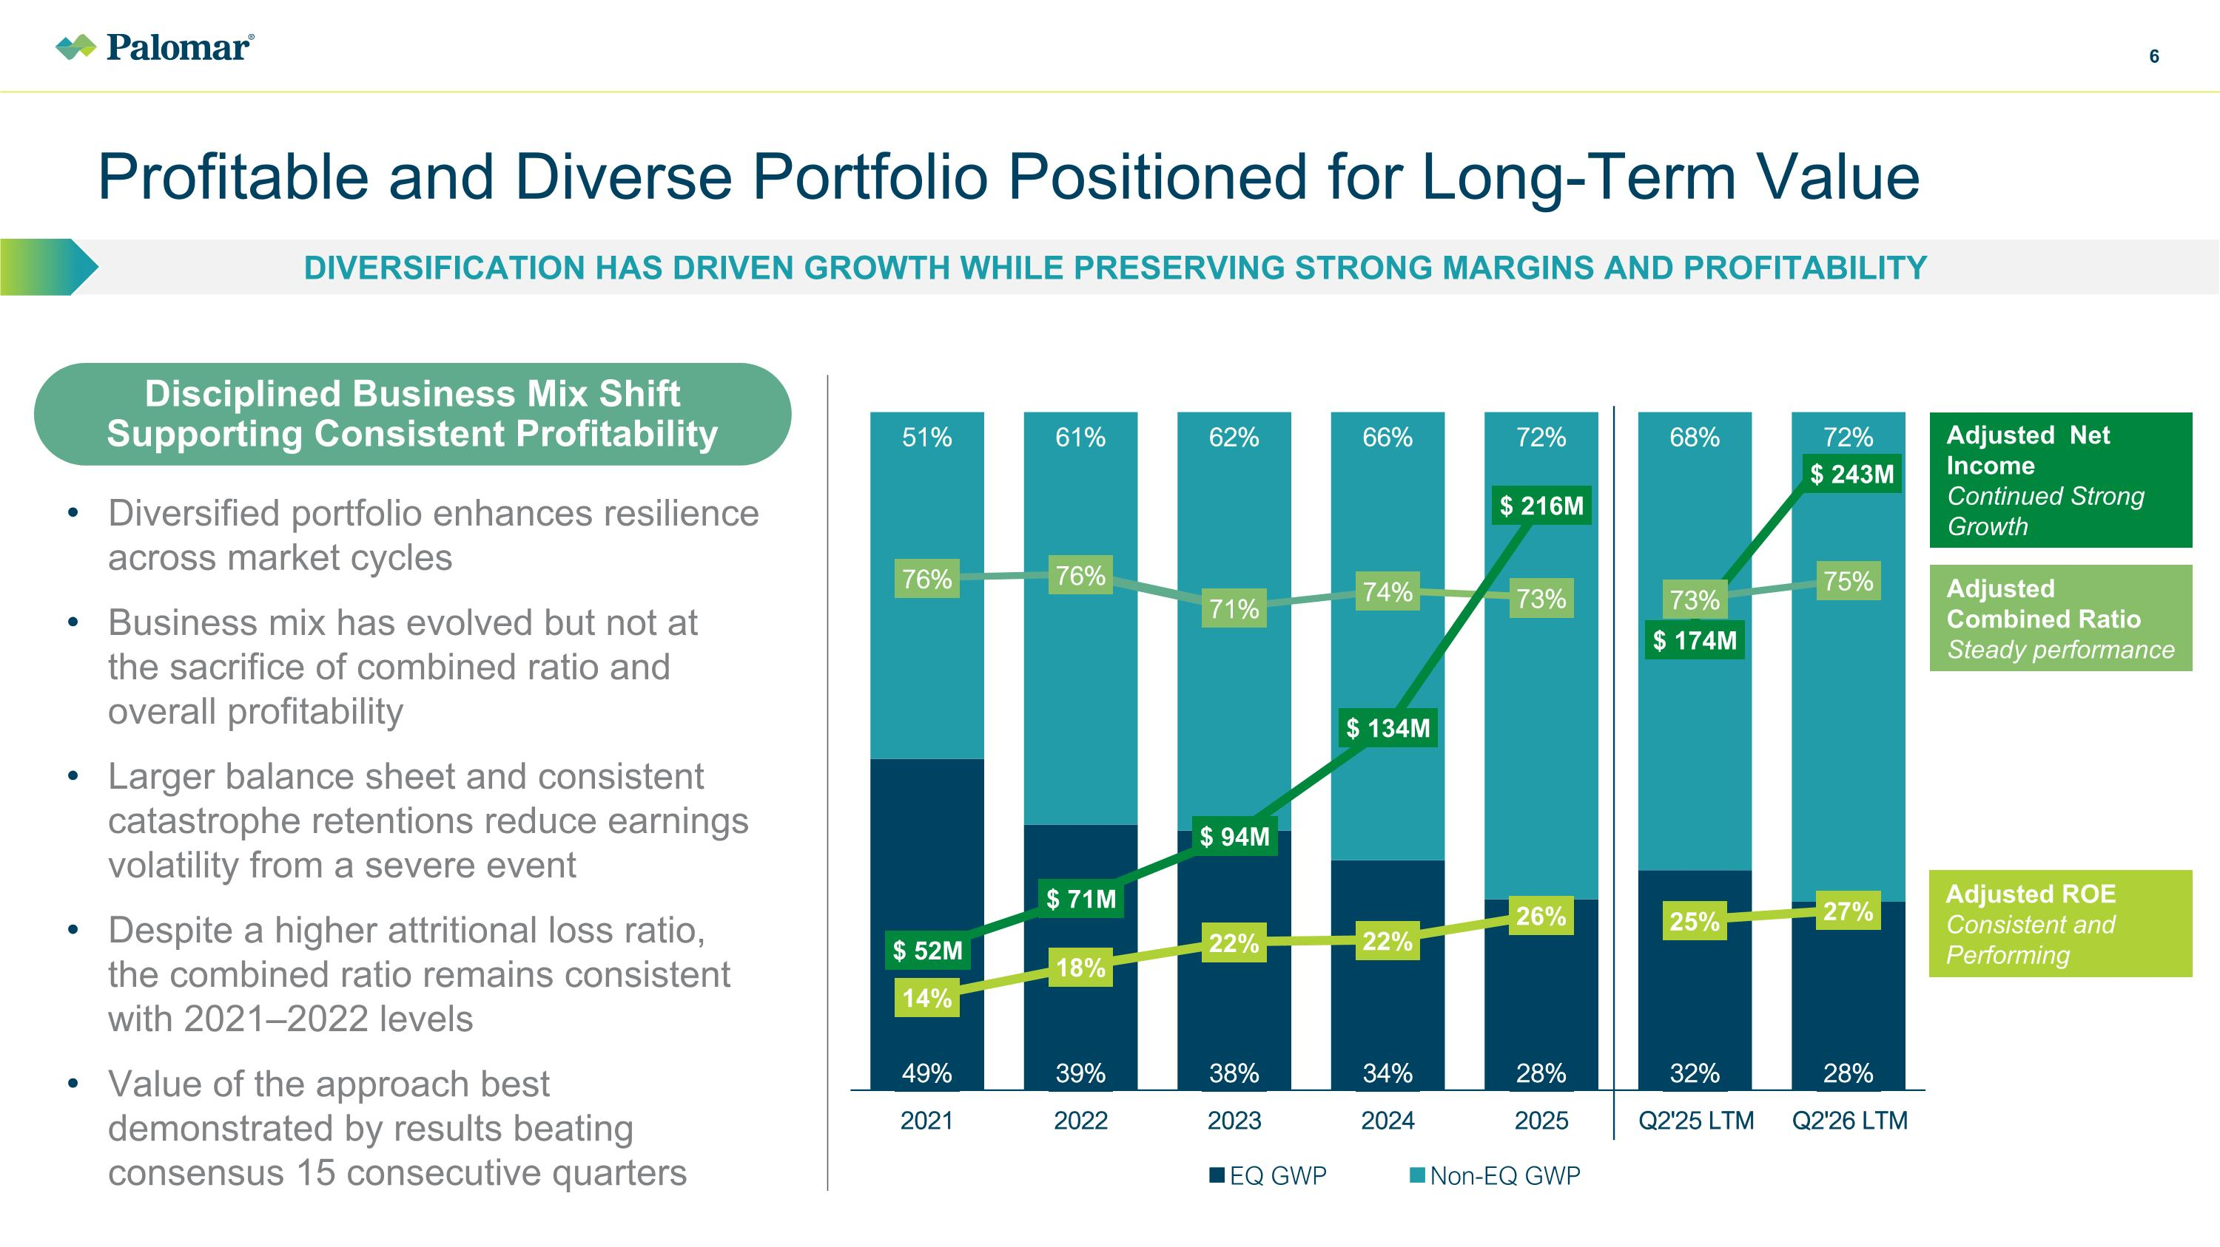
Profitable and Diverse Portfolio Positioned for Long-Term Value Diversification has driven growth while preserving strong margins and profitability Disciplined Business Mix Shift Supporting Consistent Profitability Diversified portfolio enhances resilience across market cycles Business mix has evolved but not at the sacrifice of combined ratio and overall profitability Larger balance sheet and consistent catastrophe retentions reduce earnings volatility from a severe event Despite a higher attritional loss ratio, the combined ratio remains consistent with 2021–2022 levels Value of the approach best demonstrated by results beating consensus 15 consecutive quarters Adjusted Net Income Continued Strong Growth Adjusted Combined Ratio Steady performance Adjusted ROE Consistent and Performing

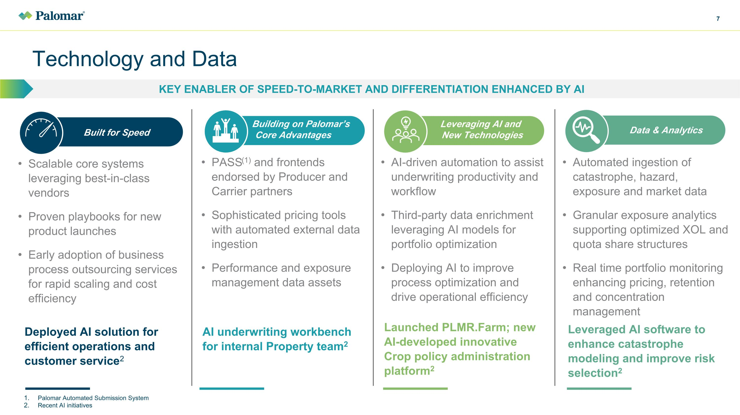
AI-driven automation to assist underwriting productivity and workflow Third-party data enrichment leveraging AI models for portfolio optimization Deploying AI to improve process optimization and drive operational efficiency Scalable core systems leveraging best-in-class vendors Proven playbooks for new product launches Early adoption of business process outsourcing services for rapid scaling and cost efficiency Technology and Data Key enabler of SPEED-TO-MARKET AND DIFFERENTIATION enhanced by ai Palomar Automated Submission System Recent AI initiatives Built for Speed Building on Palomar’s . Core Advantages PASS(1) and frontends endorsed by Producer and Carrier partners Sophisticated pricing tools with automated external data ingestion Performance and exposure management data assets Leveraging AI and .......New Technologies Automated ingestion of catastrophe, hazard, exposure and market data Granular exposure analytics supporting optimized XOL and quota share structures Real time portfolio monitoring enhancing pricing, retention and concentration management Data & Analytics AI underwriting workbench for internal Property team2 Deployed AI solution for efficient operations and customer service2 Leveraged AI software to enhance catastrophe modeling and improve risk selection2 Launched PLMR.Farm; new AI-developed innovative Crop policy administration platform2

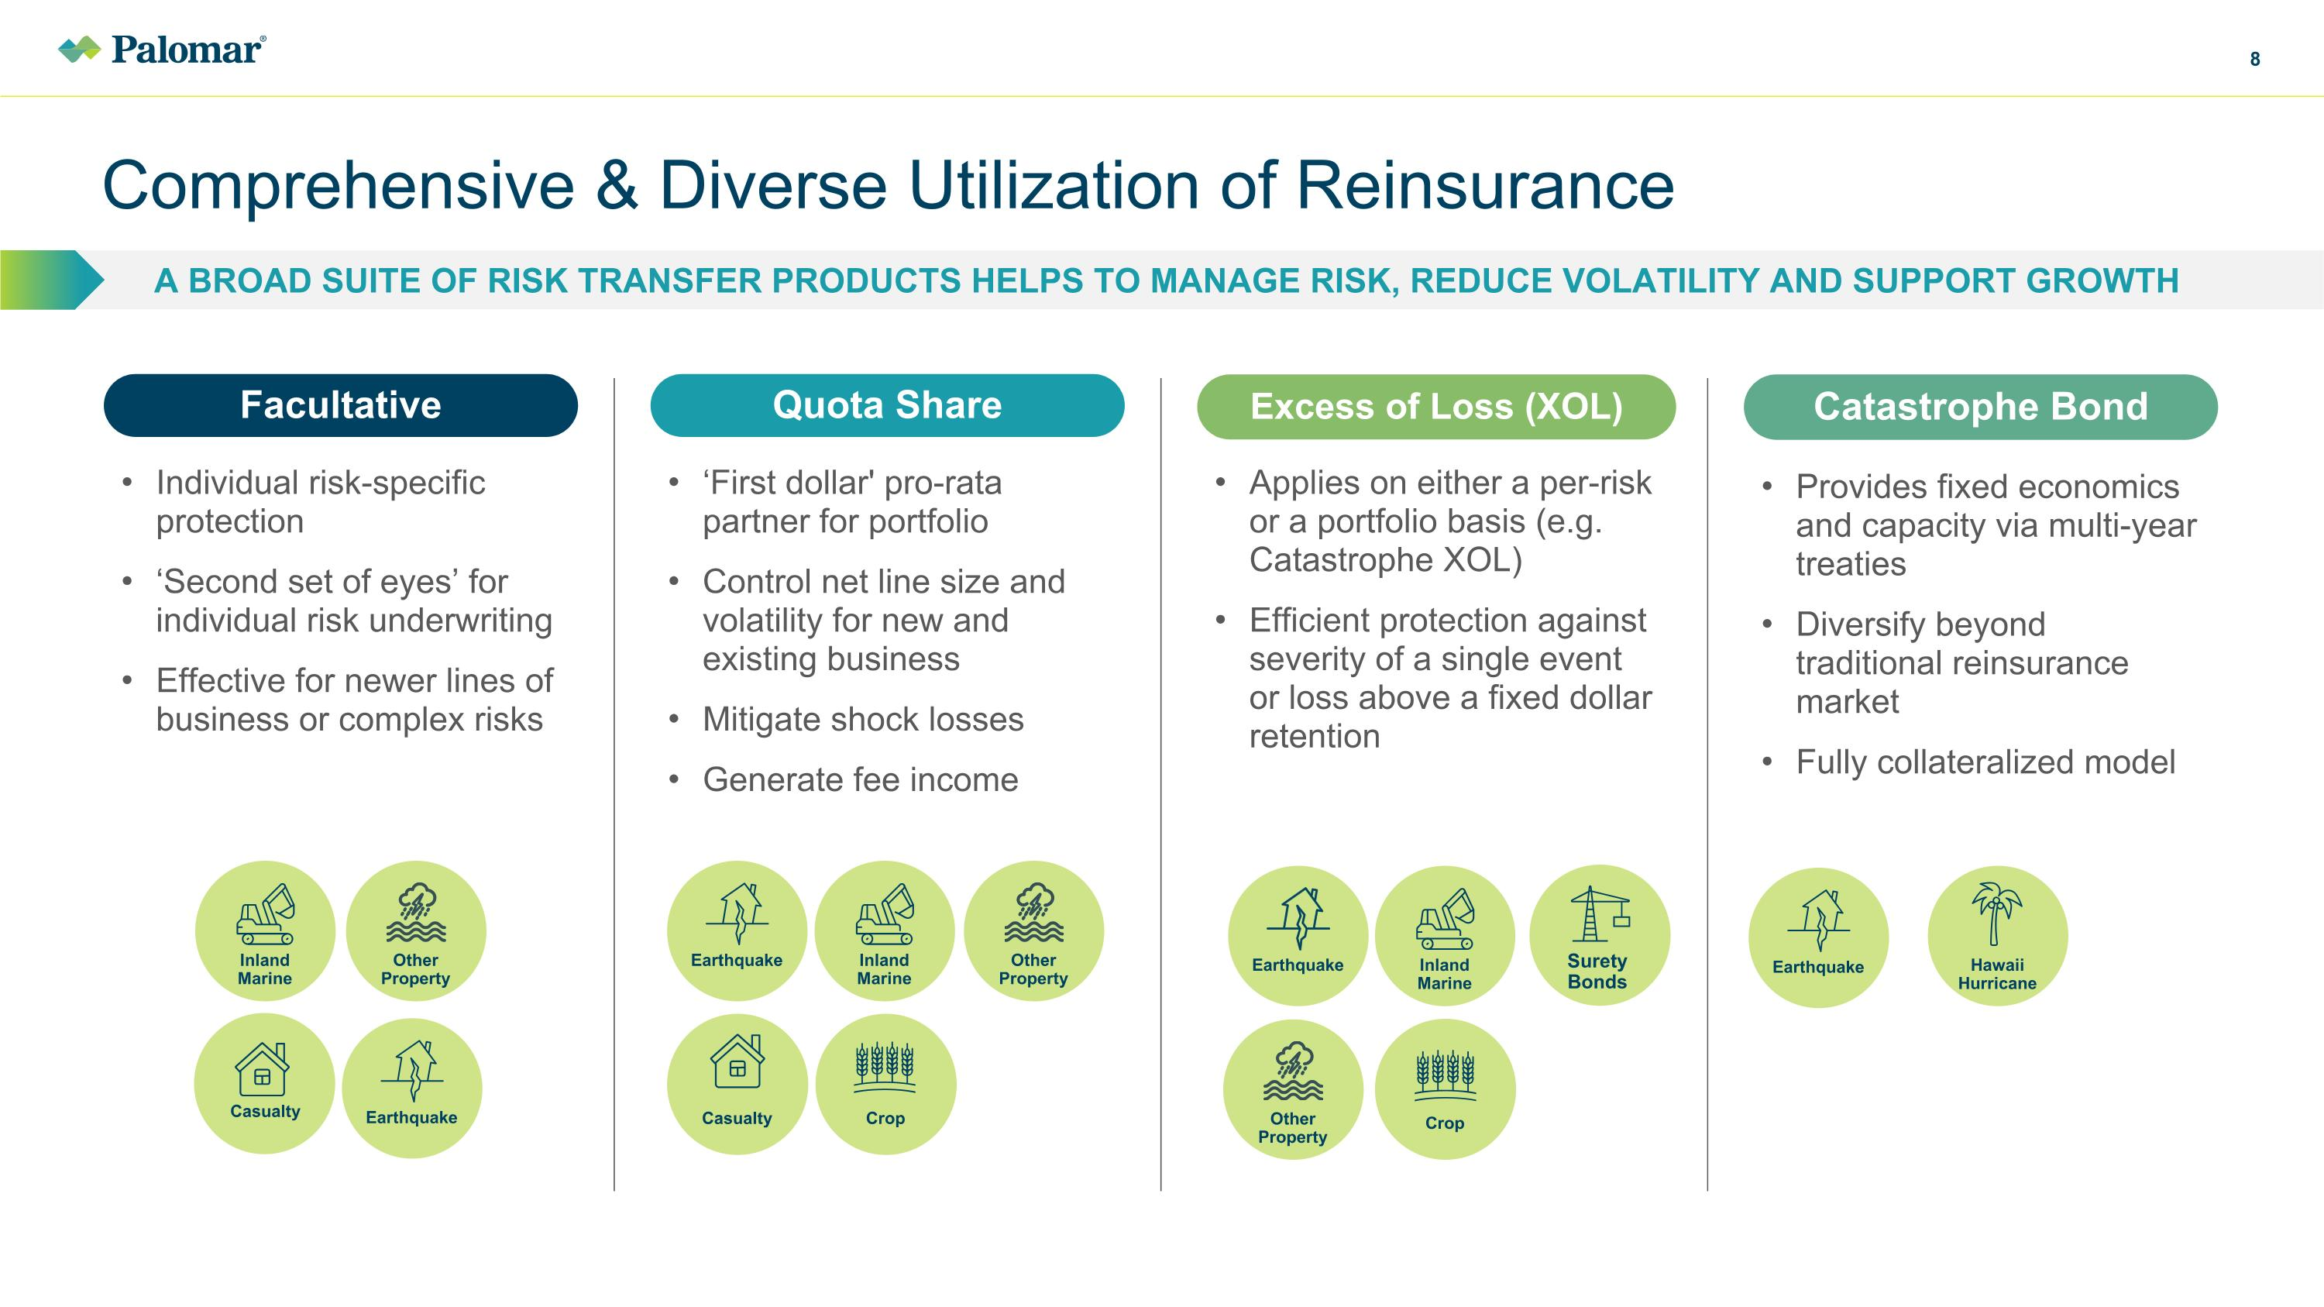
Comprehensive & Diverse Utilization of Reinsurance A Broad SUITE OF Risk Transfer PRODUCTS helps to MANAGE RISK, REDUCE VOLATILITY AND SUPPORT GROWTH Inland?Marine Other ?Property Casualty Other ?Property Inland?Marine Earthquake Casualty Crop Facultative Individual risk-specific protection ‘Second set of eyes’ for individual risk underwriting Effective for newer lines of business or complex risks Excess of Loss (XOL) Applies on either a per-risk or a portfolio basis (e.g. Catastrophe XOL) Efficient protection against severity of a single event or loss above a fixed dollar retention Quota Share ‘First dollar' pro-rata partner for portfolio Control net line size and volatility for new and existing business Mitigate shock losses Generate fee income Catastrophe Bond Provides fixed economics and capacity via multi-year treaties Diversify beyond traditional reinsurance market Fully collateralized model Earthquake Other ?Property Earthquake Crop Inland?Marine Earthquake Hawaii Hurricane Surety Bonds

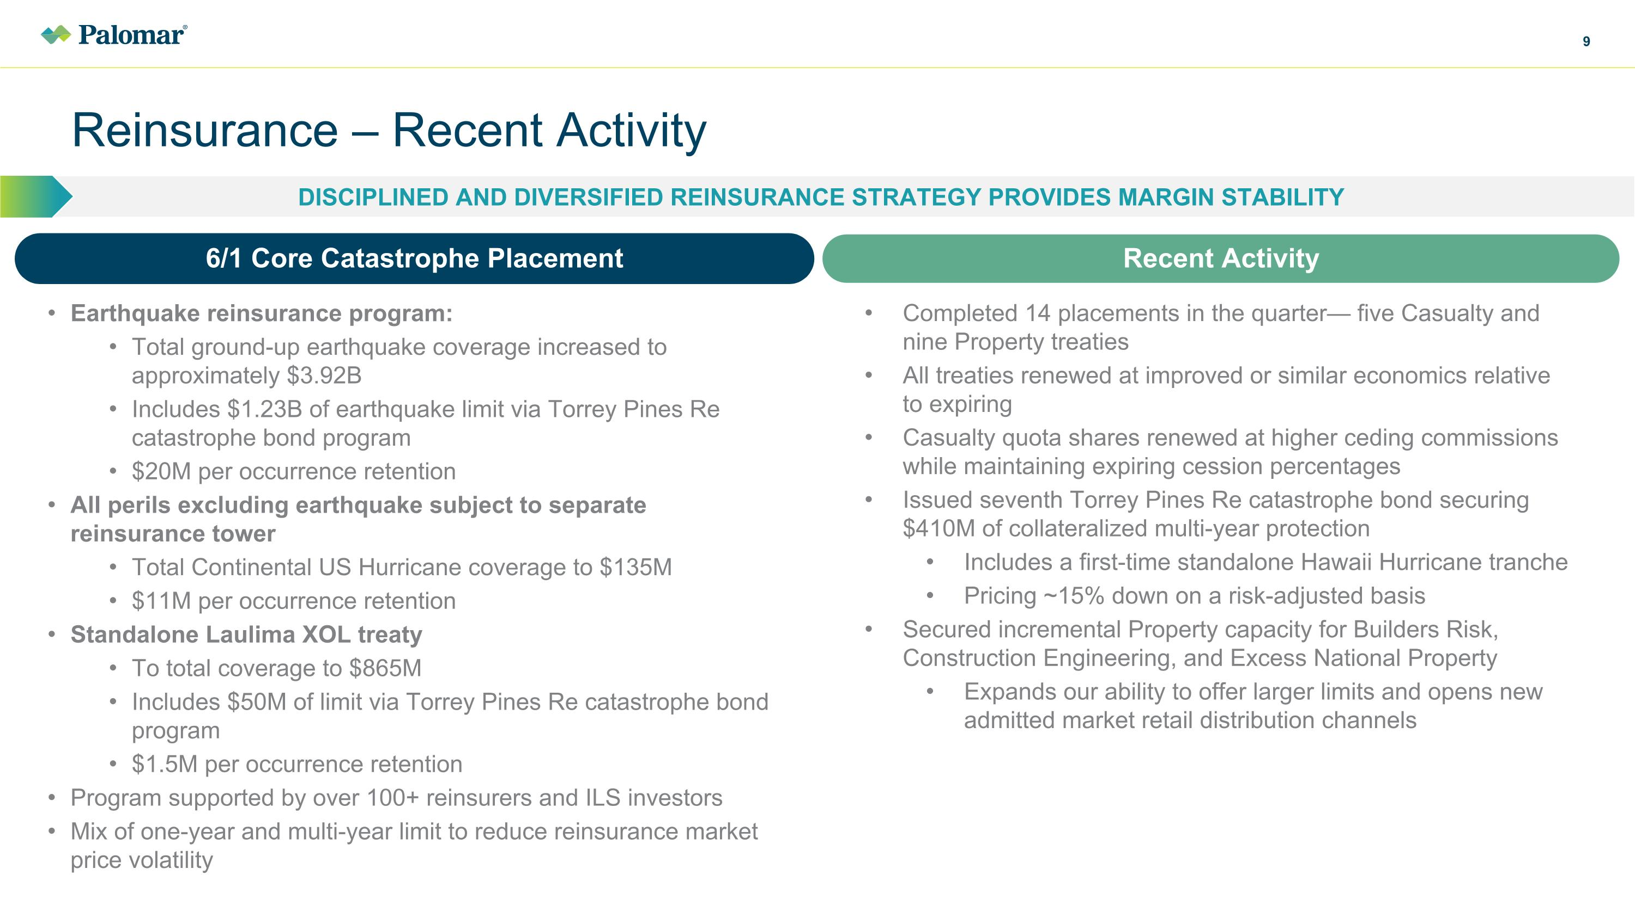
Reinsurance – Recent Activity Disciplined and Diversified Reinsurance Strategy Provides Margin Stability Completed 14 placements in the quarter— five Casualty and nine Property treaties All treaties renewed at improved or similar economics relative to expiring Casualty quota shares renewed at higher ceding commissions while maintaining expiring cession percentages Issued seventh Torrey Pines Re catastrophe bond securing $410M of collateralized multi-year protection Includes a first-time standalone Hawaii Hurricane tranche Pricing ~15% down on a risk-adjusted basis Secured incremental Property capacity for Builders Risk, Construction Engineering, and Excess National Property Expands our ability to offer larger limits and opens new admitted market retail distribution channels Earthquake reinsurance program: Total ground-up earthquake coverage increased to approximately $3.92B Includes $1.23B of earthquake limit via Torrey Pines Re catastrophe bond program $20M per occurrence retention All perils excluding earthquake subject to separate reinsurance tower Total Continental US Hurricane coverage to $135M $11M per occurrence retention Standalone Laulima XOL treaty To total coverage to $865M Includes $50M of limit via Torrey Pines Re catastrophe bond program $1.5M per occurrence retention Program supported by over 100+ reinsurers and ILS investors Mix of one-year and multi-year limit to reduce reinsurance market price volatility 6/1 Core Catastrophe Placement Recent Activity

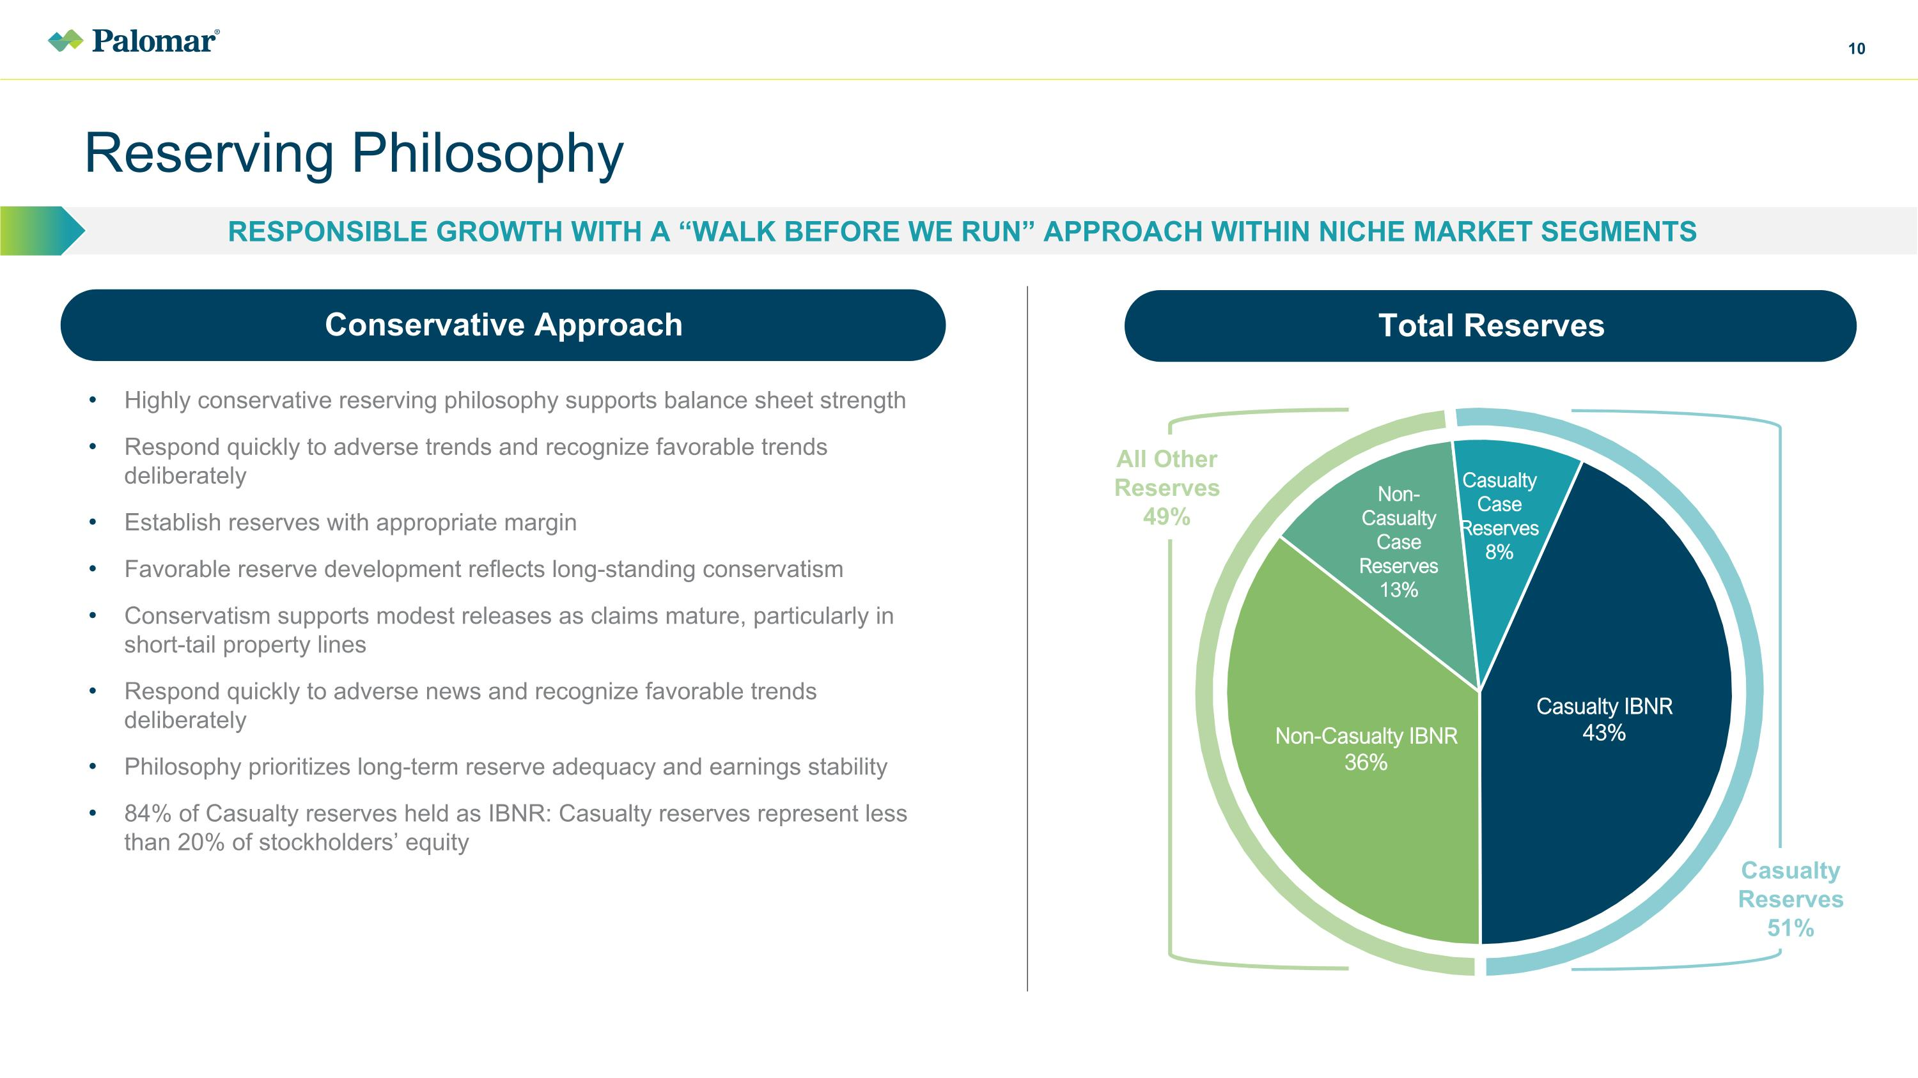
Reserving Philosophy Responsible growth with a “Walk before we run” approach within niche market segments Conservative Approach Highly conservative reserving philosophy supports balance sheet strength Respond quickly to adverse trends and recognize favorable trends deliberately Establish reserves with appropriate margin Favorable reserve development reflects long-standing conservatism Conservatism supports modest releases as claims mature, particularly in short-tail property lines Respond quickly to adverse news and recognize favorable trends deliberately Philosophy prioritizes long-term reserve adequacy and earnings stability 84% of Casualty reserves held as IBNR: Casualty reserves represent less than 20% of stockholders’ equity All Other Reserves 49% Casualty Reserves 51% Total Reserves

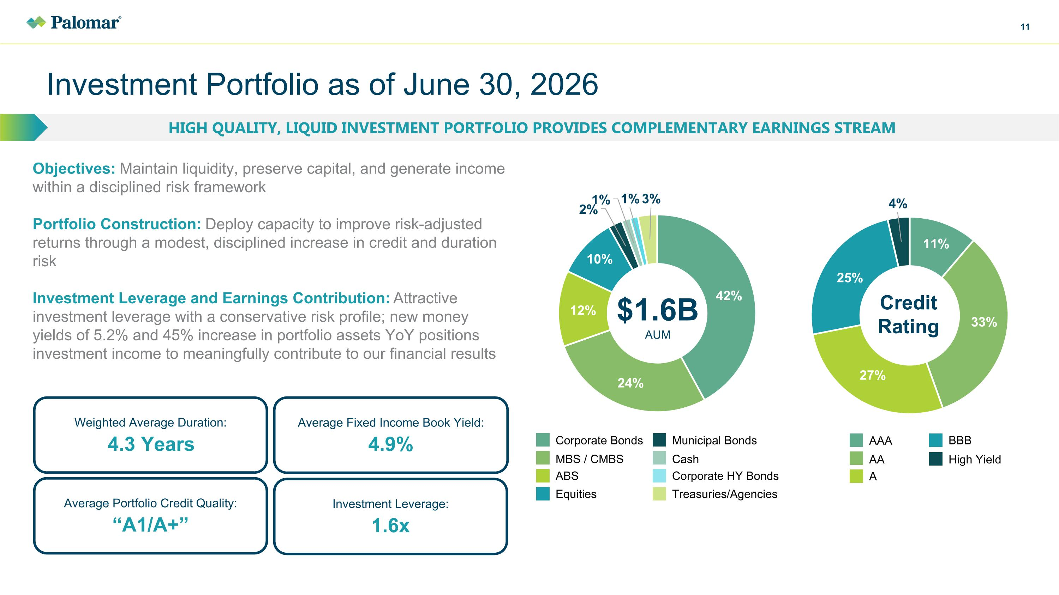
Investment Portfolio as of June 30, 2026 High quality, liquid investment portfolio provides complementary earnings stream Objectives: Maintain liquidity, preserve capital, and generate income within a disciplined risk framework Portfolio Construction: Deploy capacity to improve risk-adjusted returns through a modest, disciplined increase in credit and duration risk Investment Leverage and Earnings Contribution: Attractive investment leverage with a conservative risk profile; new money yields of 5.2% and 45% increase in portfolio assets YoY positions investment income to meaningfully contribute to our financial results Weighted Average Duration: 4.3 Years Average Portfolio Credit Quality: “A1/A+” Average Fixed Income Book Yield: 4.9% Investment Leverage: 1.6x Credit Rating AAA A AA BBB High Yield $1.6B?AUM Corporate Bonds Municipal Bonds ABS Corporate HY Bonds MBS / CMBS Cash Equities Treasuries/Agencies

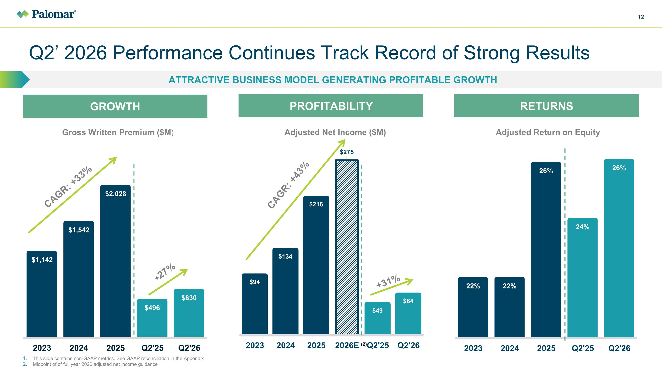
Q2’ 2026 Performance Continues Track Record of Strong Results ATTRACTIVE BUSINESS MODEL GENERATING PROFITABLE GROWTH GROWTH PROFITABILITY Gross Written Premium ($M) Adjusted Return on Equity Adjusted Net Income ($M) CAGR: +33% CAGR: +43% +31% This slide contains non-GAAP metrics. See GAAP reconciliation in the Appendix Midpoint of of full year 2026 adjusted net income guidance +27% RETURNS (2)

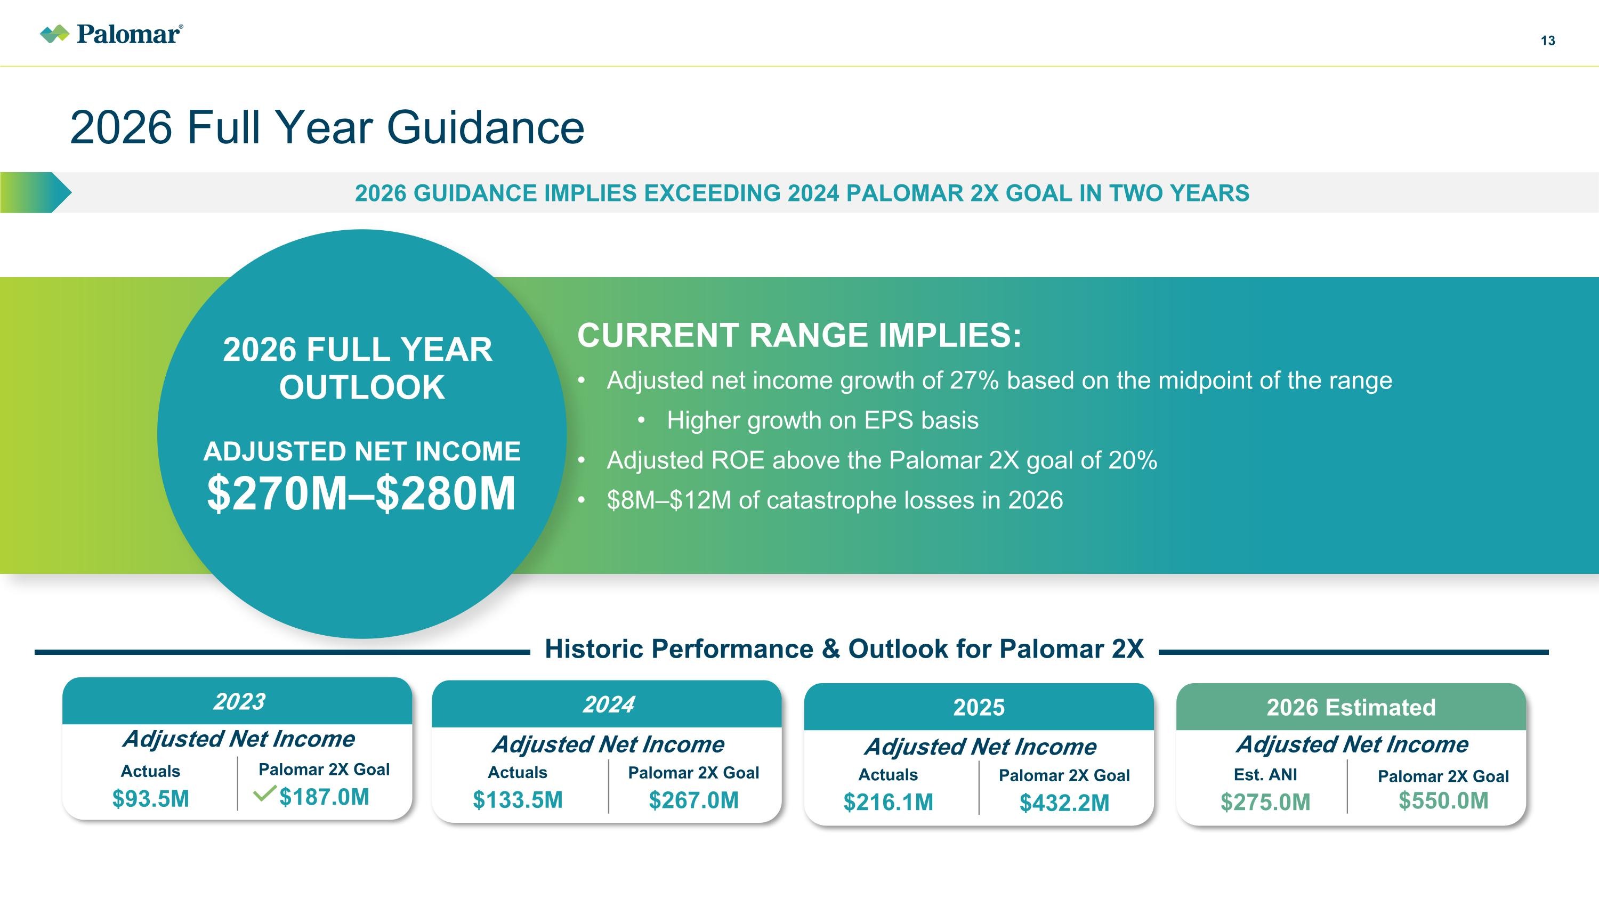
2026 Full Year Guidance 2026 Guidance implies exceeding 2024 Palomar 2X goal in two years 2026 FULL YEAR ?OUTLOOK Adjusted Net Income?$270M–$280M Current range IMPLIES: Adjusted net income growth of 27% based on the midpoint of the range Higher growth on EPS basis Adjusted ROE above the Palomar 2X goal of 20% $8M–$12M of catastrophe losses in 2026 2024 2026 Estimated 2023 Actuals $93.5M Adjusted Net Income 2025 Palomar 2X Goal $187.0M Adjusted Net Income Actuals $133.5M Palomar 2X Goal $267.0M Adjusted Net Income Actuals $216.1M Palomar 2X Goal $432.2M Adjusted Net Income Est. ANI $275.0M Palomar 2X Goal?$550.0M Historic Performance & Outlook for Palomar 2X

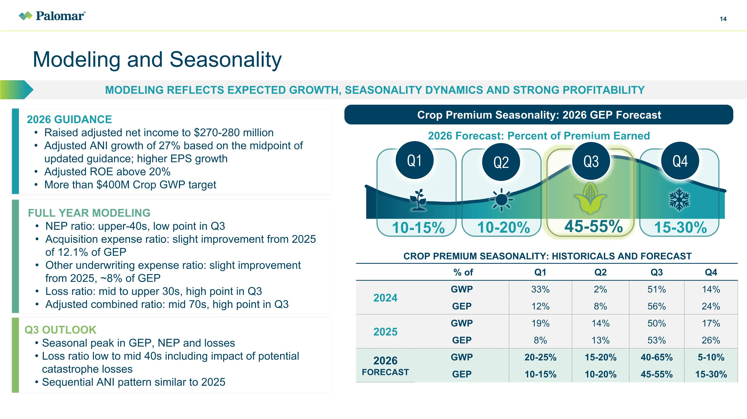
Modeling and Seasonality Modeling reflects expected growth, seasonality dynamics and strong profitability Q1 Q2 Q4 10-15% 10-20% 15-30% 45-55% Crop Premium Seasonality: 2026 GEP Forecast 2026 Forecast: Percent of Premium Earned Q3 Q3 OUTLOOK Seasonal peak in GEP, NEP and losses Loss ratio low to mid 40s including impact of potential catastrophe losses Sequential ANI pattern similar to 2025 2026 GUIDANCE Raised adjusted net income to $270-280 million Adjusted ANI growth of 27% based on the midpoint of updated guidance; higher EPS growth Adjusted ROE above 20% More than $400M Crop GWP target FULL YEAR MODELING NEP ratio: upper-40s, low point in Q3 Acquisition expense ratio: slight improvement from 2025 of 12.1% of GEP Other underwriting expense ratio: slight improvement from 2025, ~8% of GEP Loss ratio: mid to upper 30s, high point in Q3 Adjusted combined ratio: mid 70s, high point in Q3 CROP PREMIUM SEASONALITY: HISTORICALS AND FORECAST % of Q1 Q2 Q3 Q4 2024 GWP 33% 2% 51% 14% GEP 12% 8% 56% 24% 2025 GWP 19% 14% 50% 17% GEP 8% 13% 53% 26% 2026 FORECAST GWP 20-25% 15-20% 40-65% 5-10% GEP 10-15% 10-20% 45-55% 15-30%

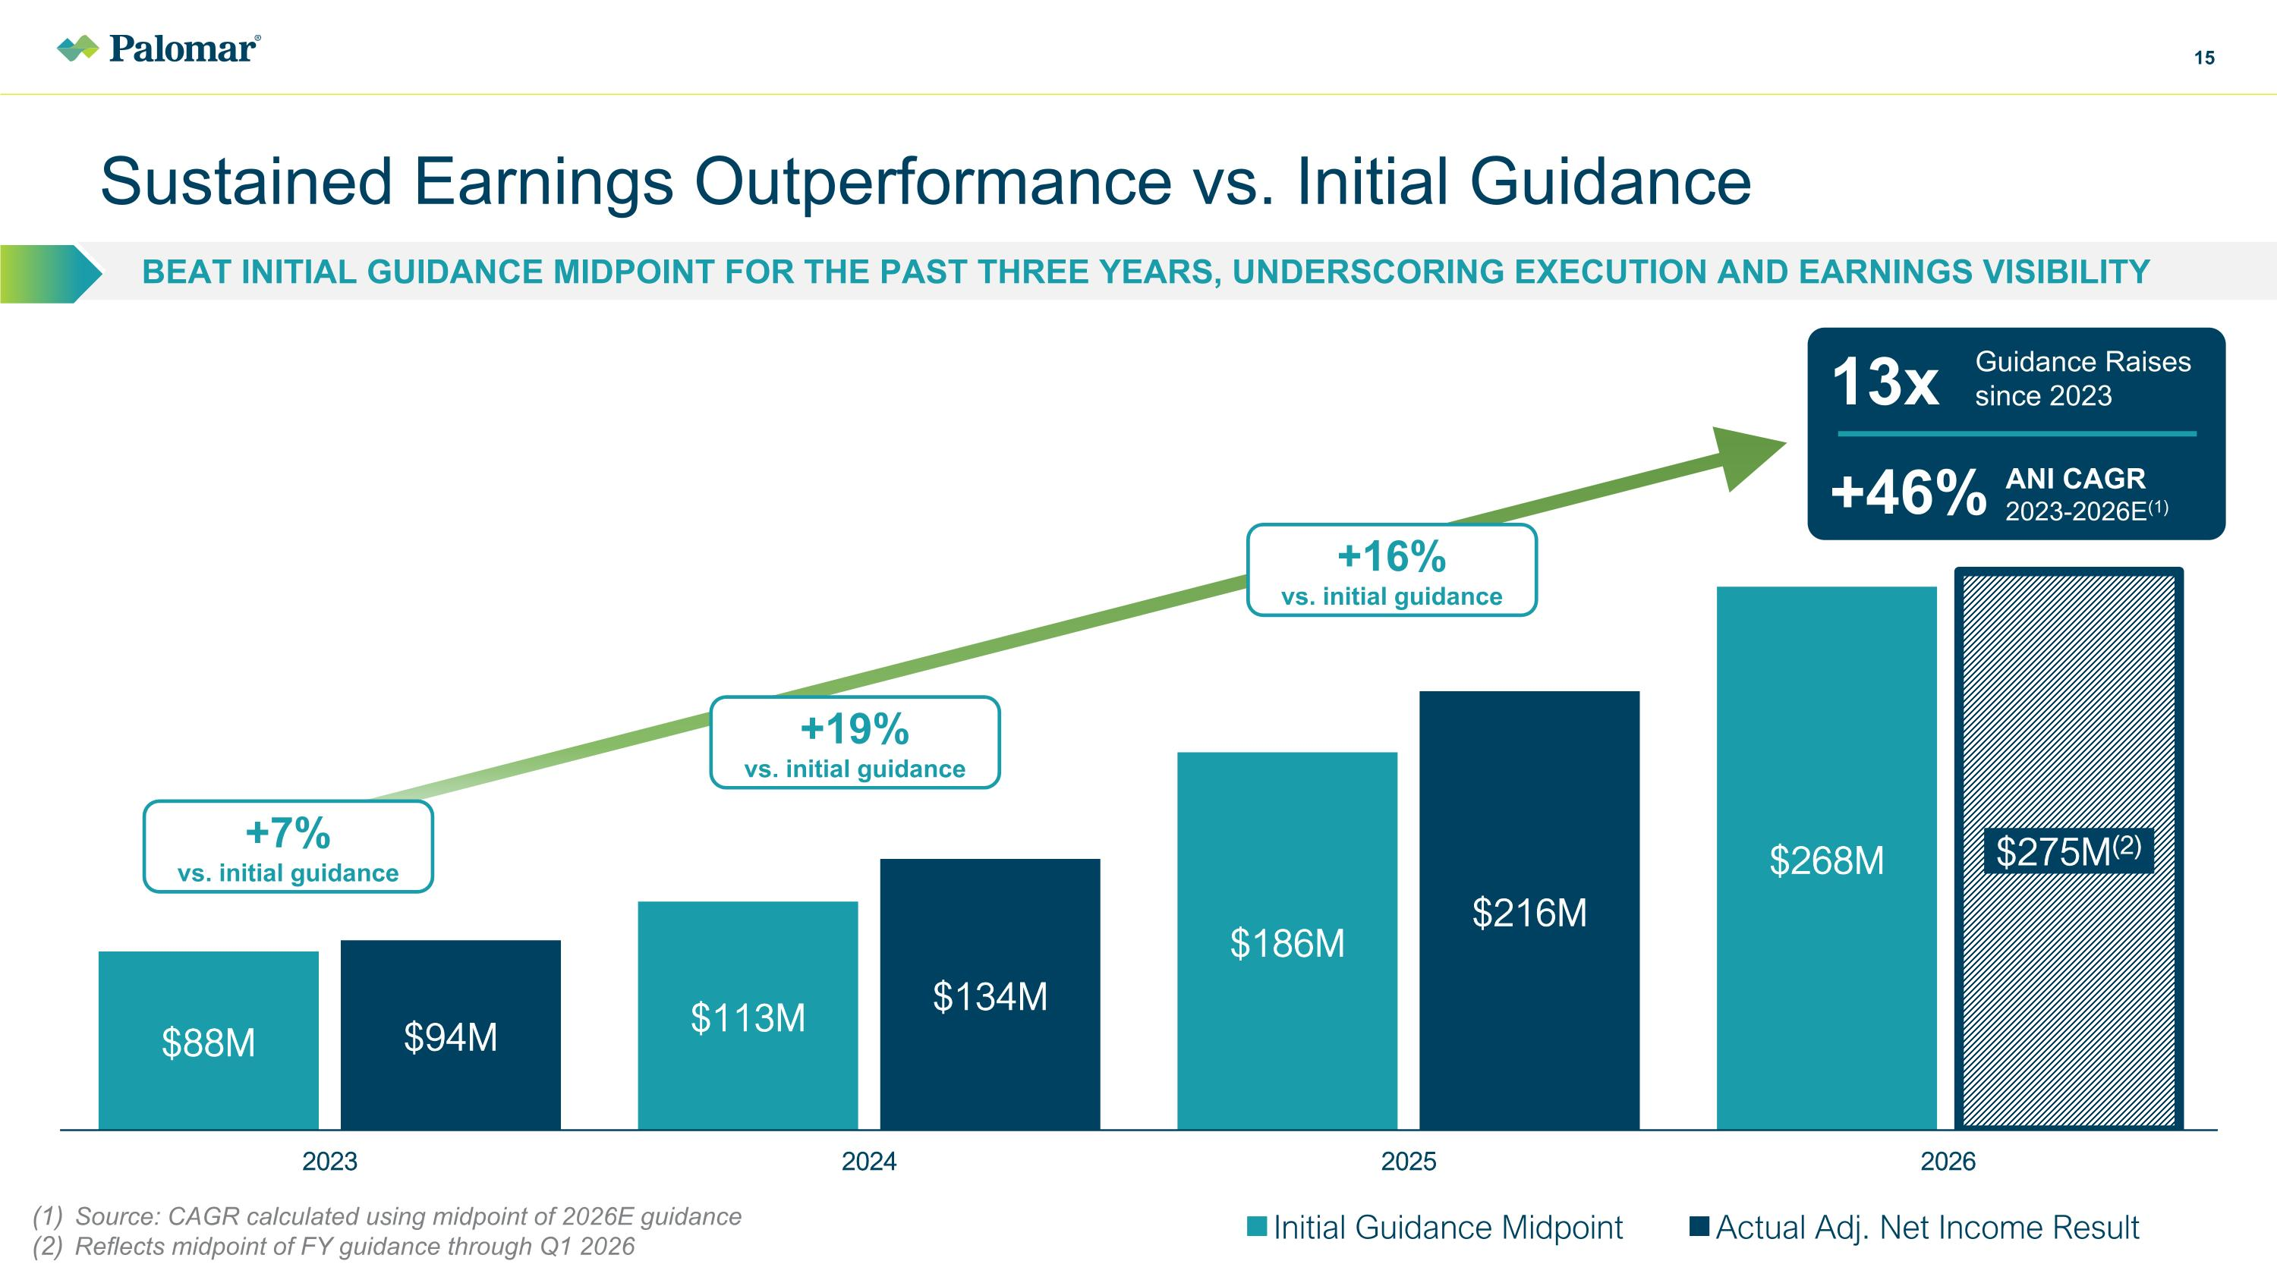
Beat Initial guidance midpoint for the past three years, underscoring execution and earnings visibility Sustained Earnings Outperformance vs. Initial Guidance +7% vs. initial guidance +19% vs. initial guidance +16% vs. initial guidance 13x +46% Guidance Raises since 2023 ANI CAGR 2023-2026E(1) Source: CAGR calculated using midpoint of 2026E guidance Reflects midpoint of FY guidance through Q1 2026

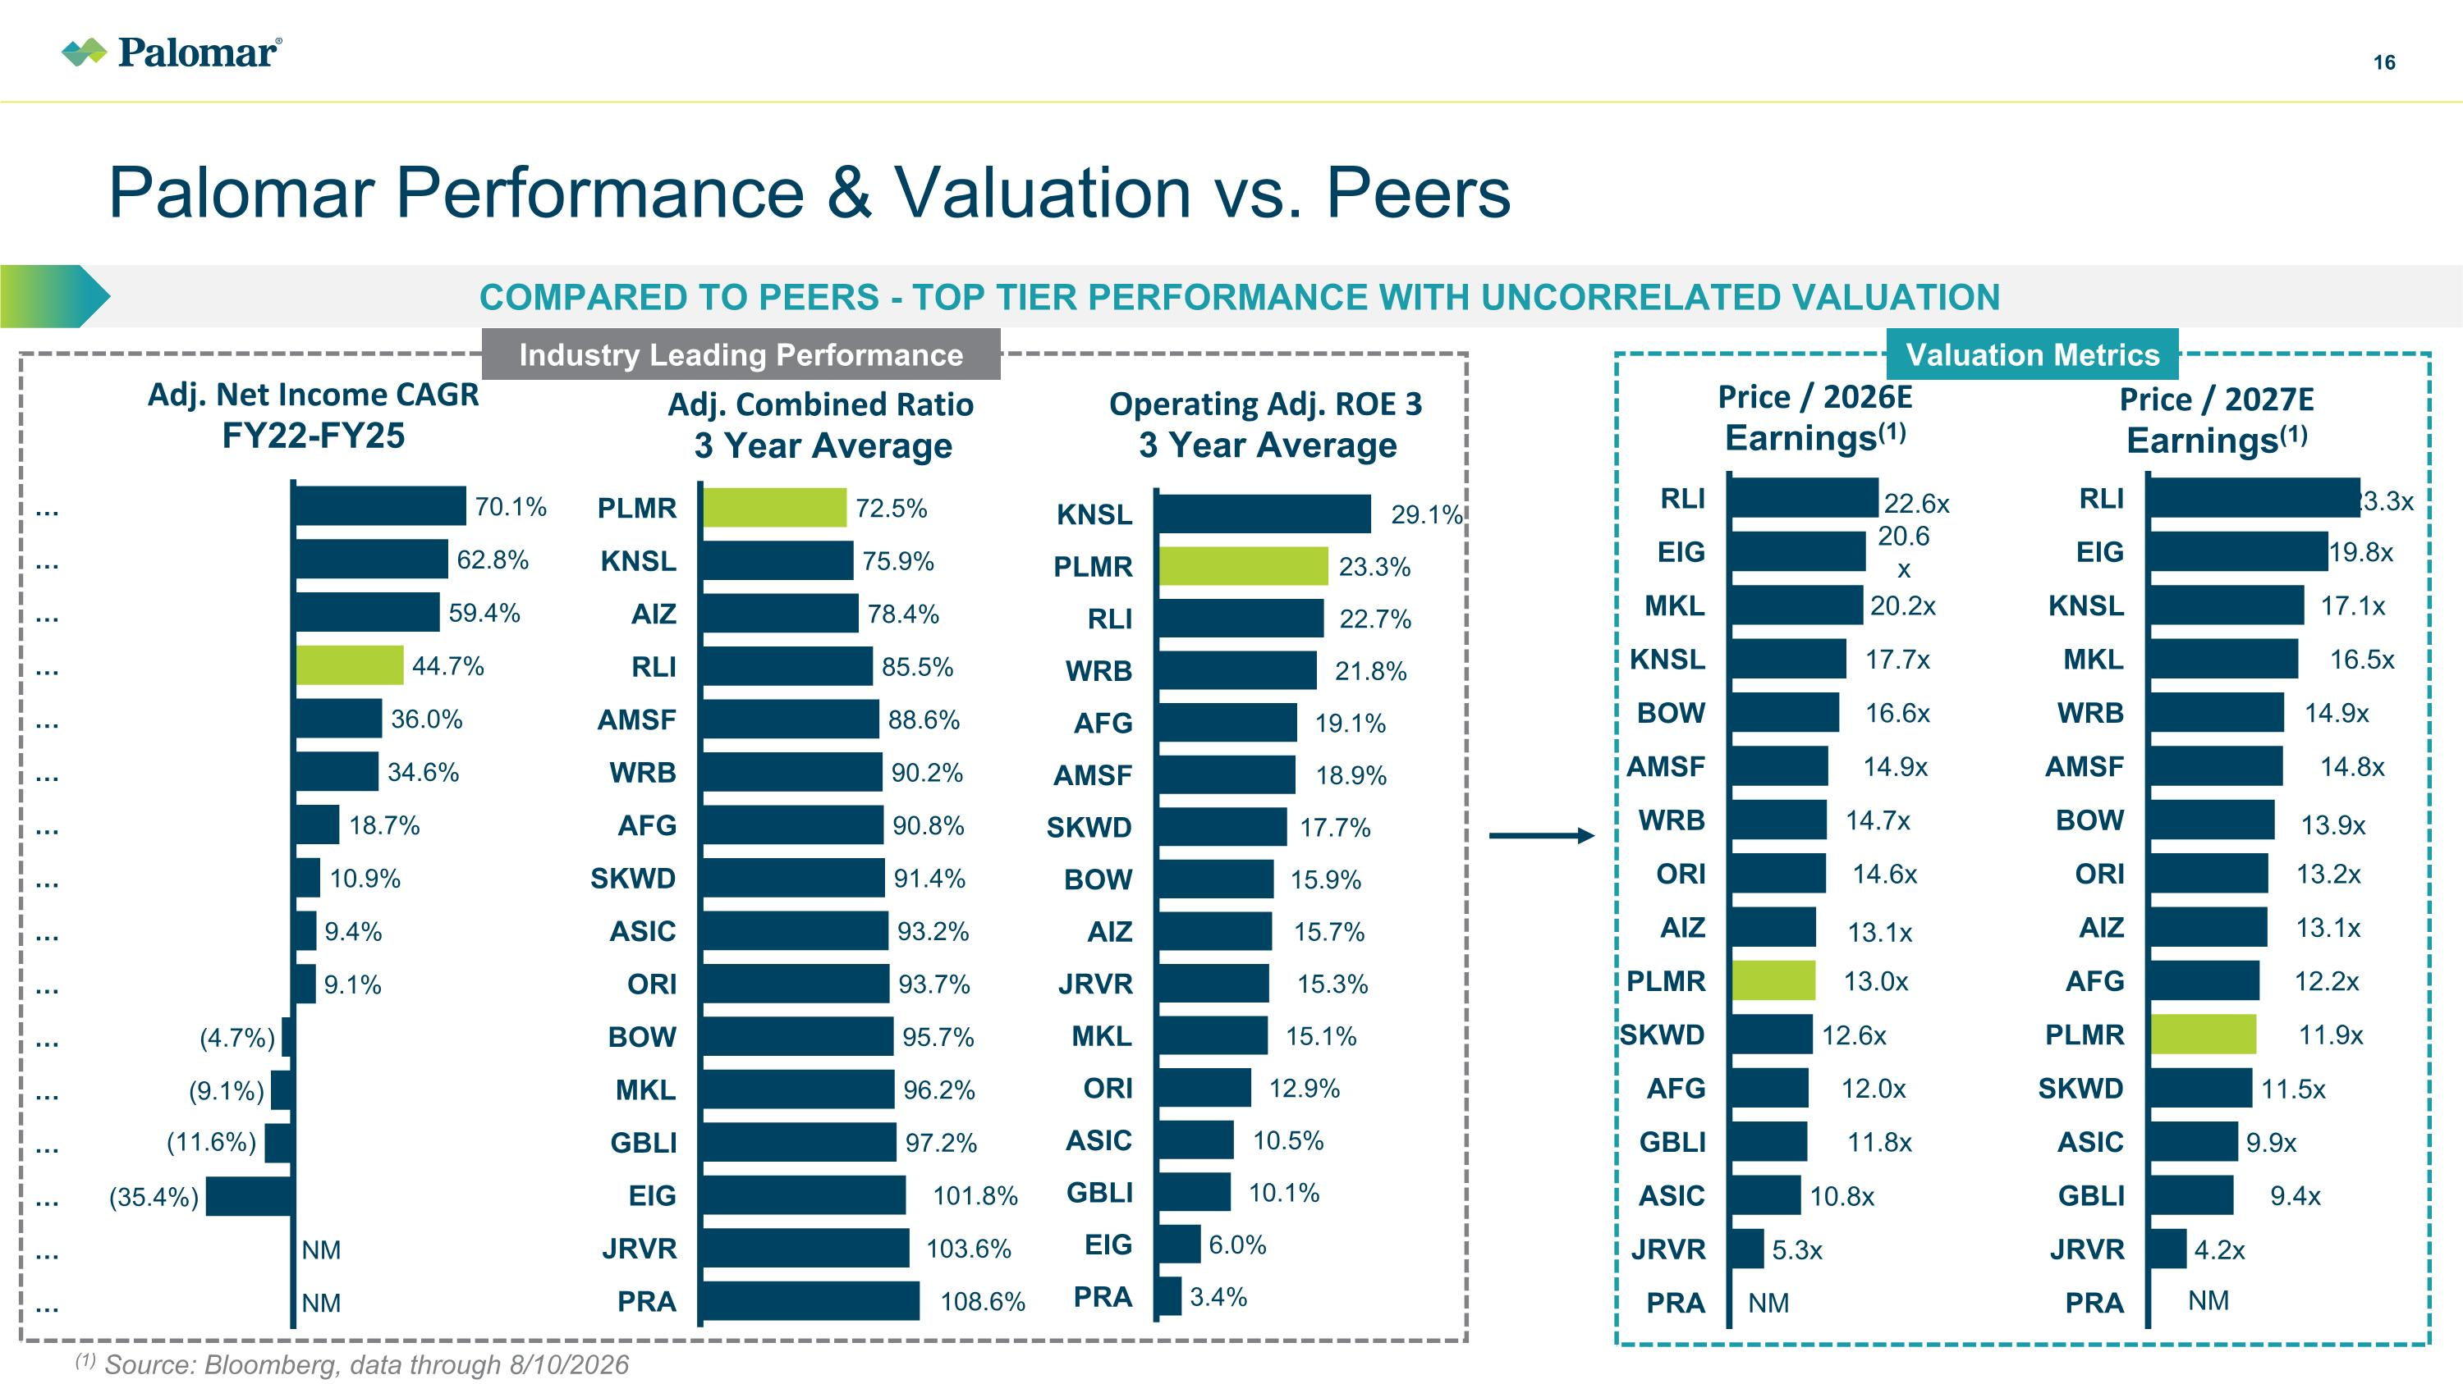
Palomar Performance & Valuation vs. Peers Compared to Peers - Top Tier Performance with Uncorrelated valuation Valuation Metrics Industry Leading Performance (1) Source: Bloomberg, data through 8/10/2026

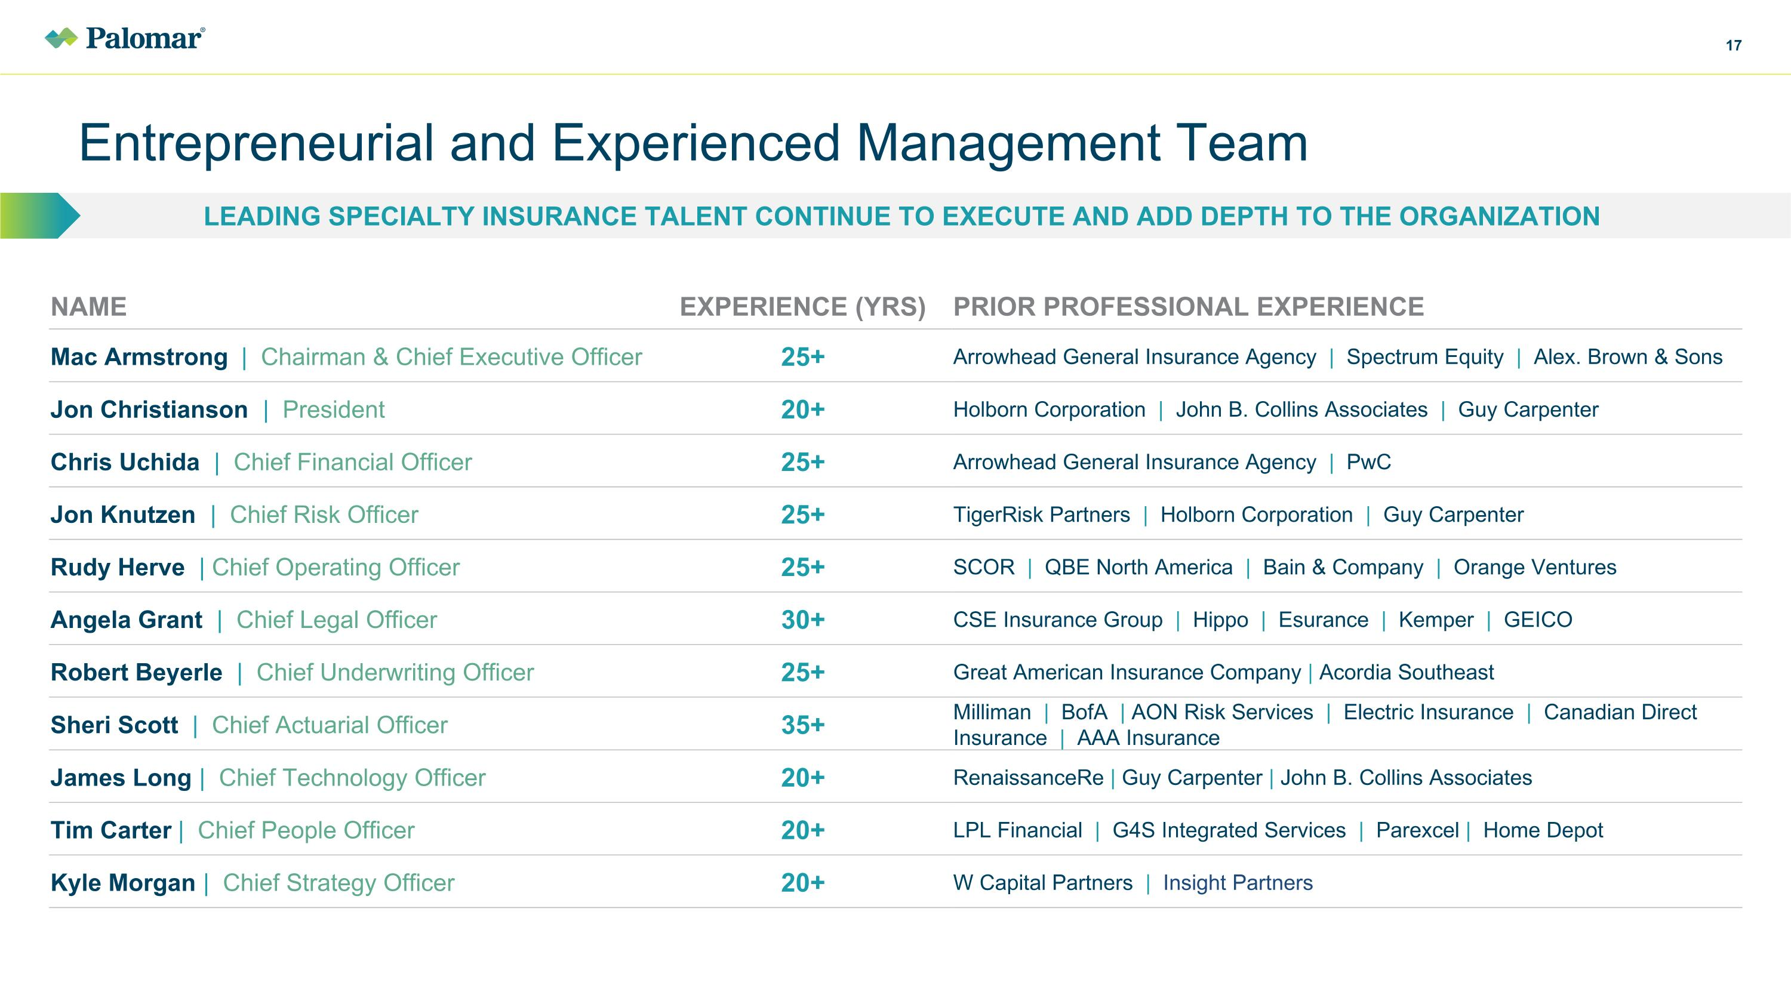
Entrepreneurial and Experienced Management Team LEADING SPECIALTY INSURANCE TALENT CONTINUE TO EXECUTE AND ADD DEPTH TO THE ORGANIZATION NAME EXPERIENCE (YRS) PRIOR PROFESSIONAL EXPERIENCE Mac Armstrong | Chairman & Chief Executive Officer 25+ Arrowhead General Insurance Agency | Spectrum Equity | Alex. Brown & Sons Jon Christianson | President 20+ Holborn Corporation | John B. Collins Associates | Guy Carpenter Chris Uchida | Chief Financial Officer 25+ Arrowhead General Insurance Agency | PwC Jon Knutzen | Chief Risk Officer 25+ TigerRisk Partners | Holborn Corporation | Guy Carpenter Rudy Herve | Chief Operating Officer 25+ SCOR | QBE North America | Bain & Company | Orange Ventures Angela Grant | Chief Legal Officer 30+ CSE Insurance Group | Hippo | Esurance | Kemper | GEICO Robert Beyerle | Chief Underwriting Officer 25+ Great American Insurance Company | Acordia Southeast Sheri Scott | Chief Actuarial Officer 35+ Milliman | BofA | AON Risk Services | Electric Insurance | Canadian Direct Insurance | AAA Insurance James Long | Chief Technology Officer 20+ RenaissanceRe | Guy Carpenter | John B. Collins Associates Tim Carter | Chief People Officer 20+ LPL Financial | G4S Integrated Services | Parexcel | Home Depot Kyle Morgan | Chief Strategy Officer 20+ W Capital Partners | Insight Partners


Appendix 2025 Investor Day | March 20, 2025

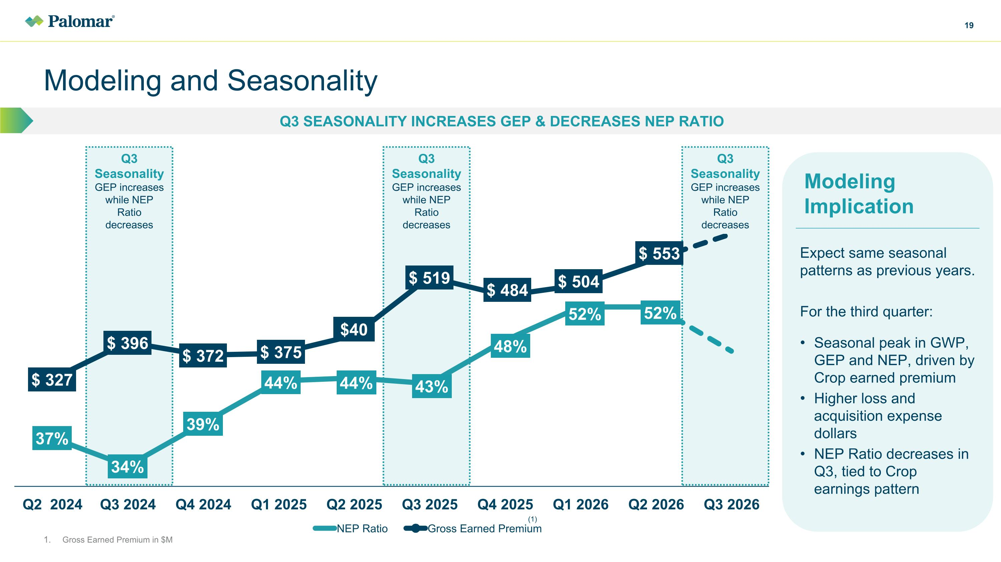
Q3 Seasonality GEP increases while NEP Ratio decreases Q3 Seasonality GEP increases while NEP Ratio decreases Q3 Seasonality GEP increases while NEP Ratio decreases Q3 seasonality increases GEP & decreases NEP Ratio Modeling and Seasonality Gross Earned Premium in $M (1) Expect same seasonal patterns as previous years. For the third quarter: Seasonal peak in GWP, GEP and NEP, driven by Crop earned premium Higher loss and acquisition expense dollars NEP Ratio decreases in Q3, tied to Crop earnings pattern Modeling Implication

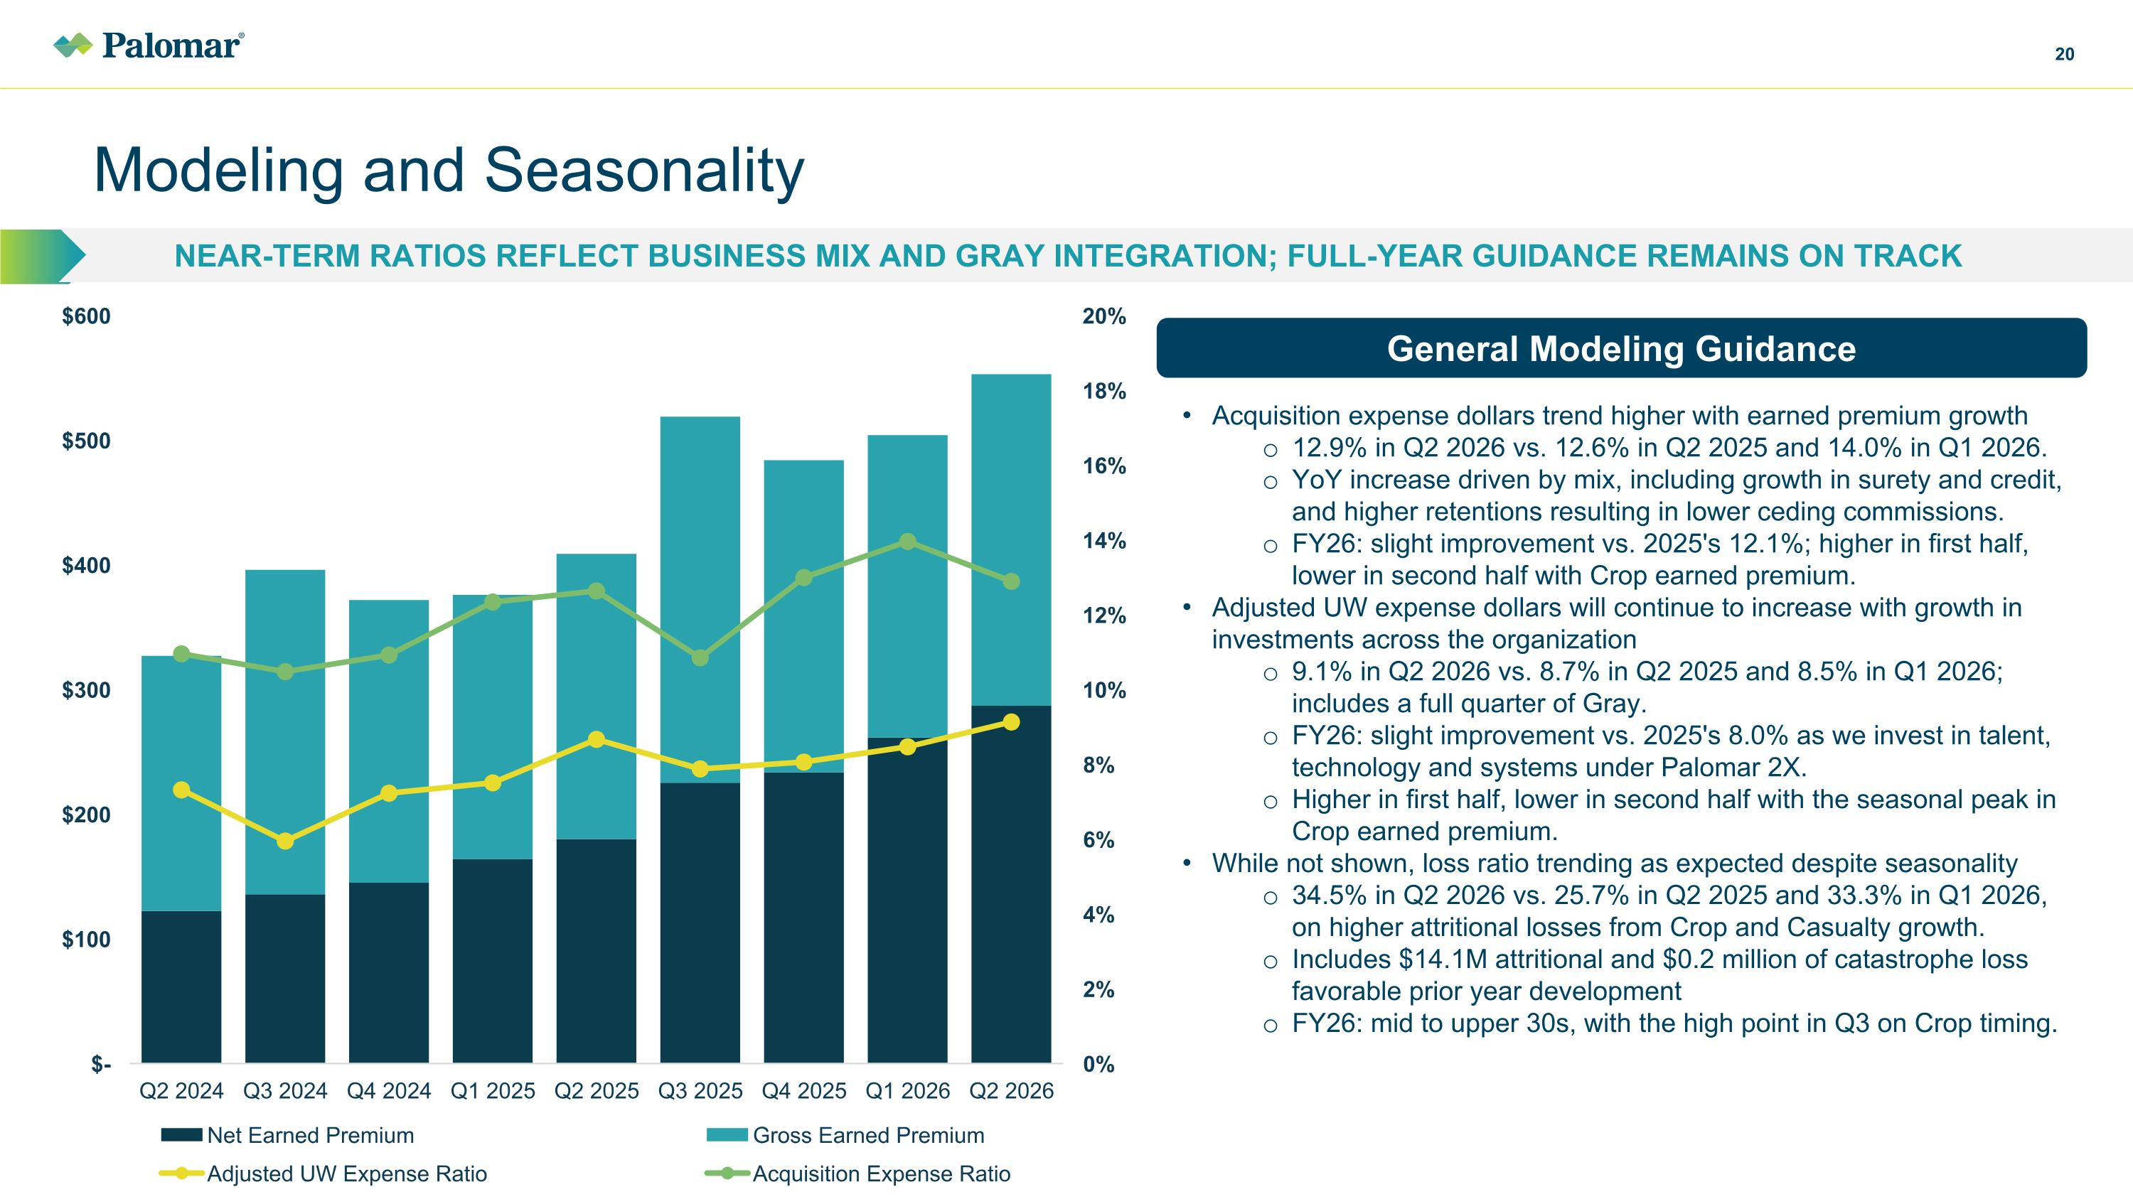
Modeling and Seasonality Near-term ratios reflect business mix and gray integration; full-year guidance remains on track Acquisition expense dollars trend higher with earned premium growth 12.9% in Q2 2026 vs. 12.6% in Q2 2025 and 14.0% in Q1 2026. YoY increase driven by mix, including growth in surety and credit, and higher retentions resulting in lower ceding commissions. FY26: slight improvement vs. 2025's 12.1%; higher in first half, lower in second half with Crop earned premium. Adjusted UW expense dollars will continue to increase with growth in investments across the organization 9.1% in Q2 2026 vs. 8.7% in Q2 2025 and 8.5% in Q1 2026; includes a full quarter of Gray. FY26: slight improvement vs. 2025's 8.0% as we invest in talent, technology and systems under Palomar 2X. Higher in first half, lower in second half with the seasonal peak in Crop earned premium. While not shown, loss ratio trending as expected despite seasonality 34.5% in Q2 2026 vs. 25.7% in Q2 2025 and 33.3% in Q1 2026, on higher attritional losses from Crop and Casualty growth. Includes $14.1M attritional and $0.2 million of catastrophe loss favorable prior year development FY26: mid to upper 30s, with the high point in Q3 on Crop timing. General Modeling Guidance

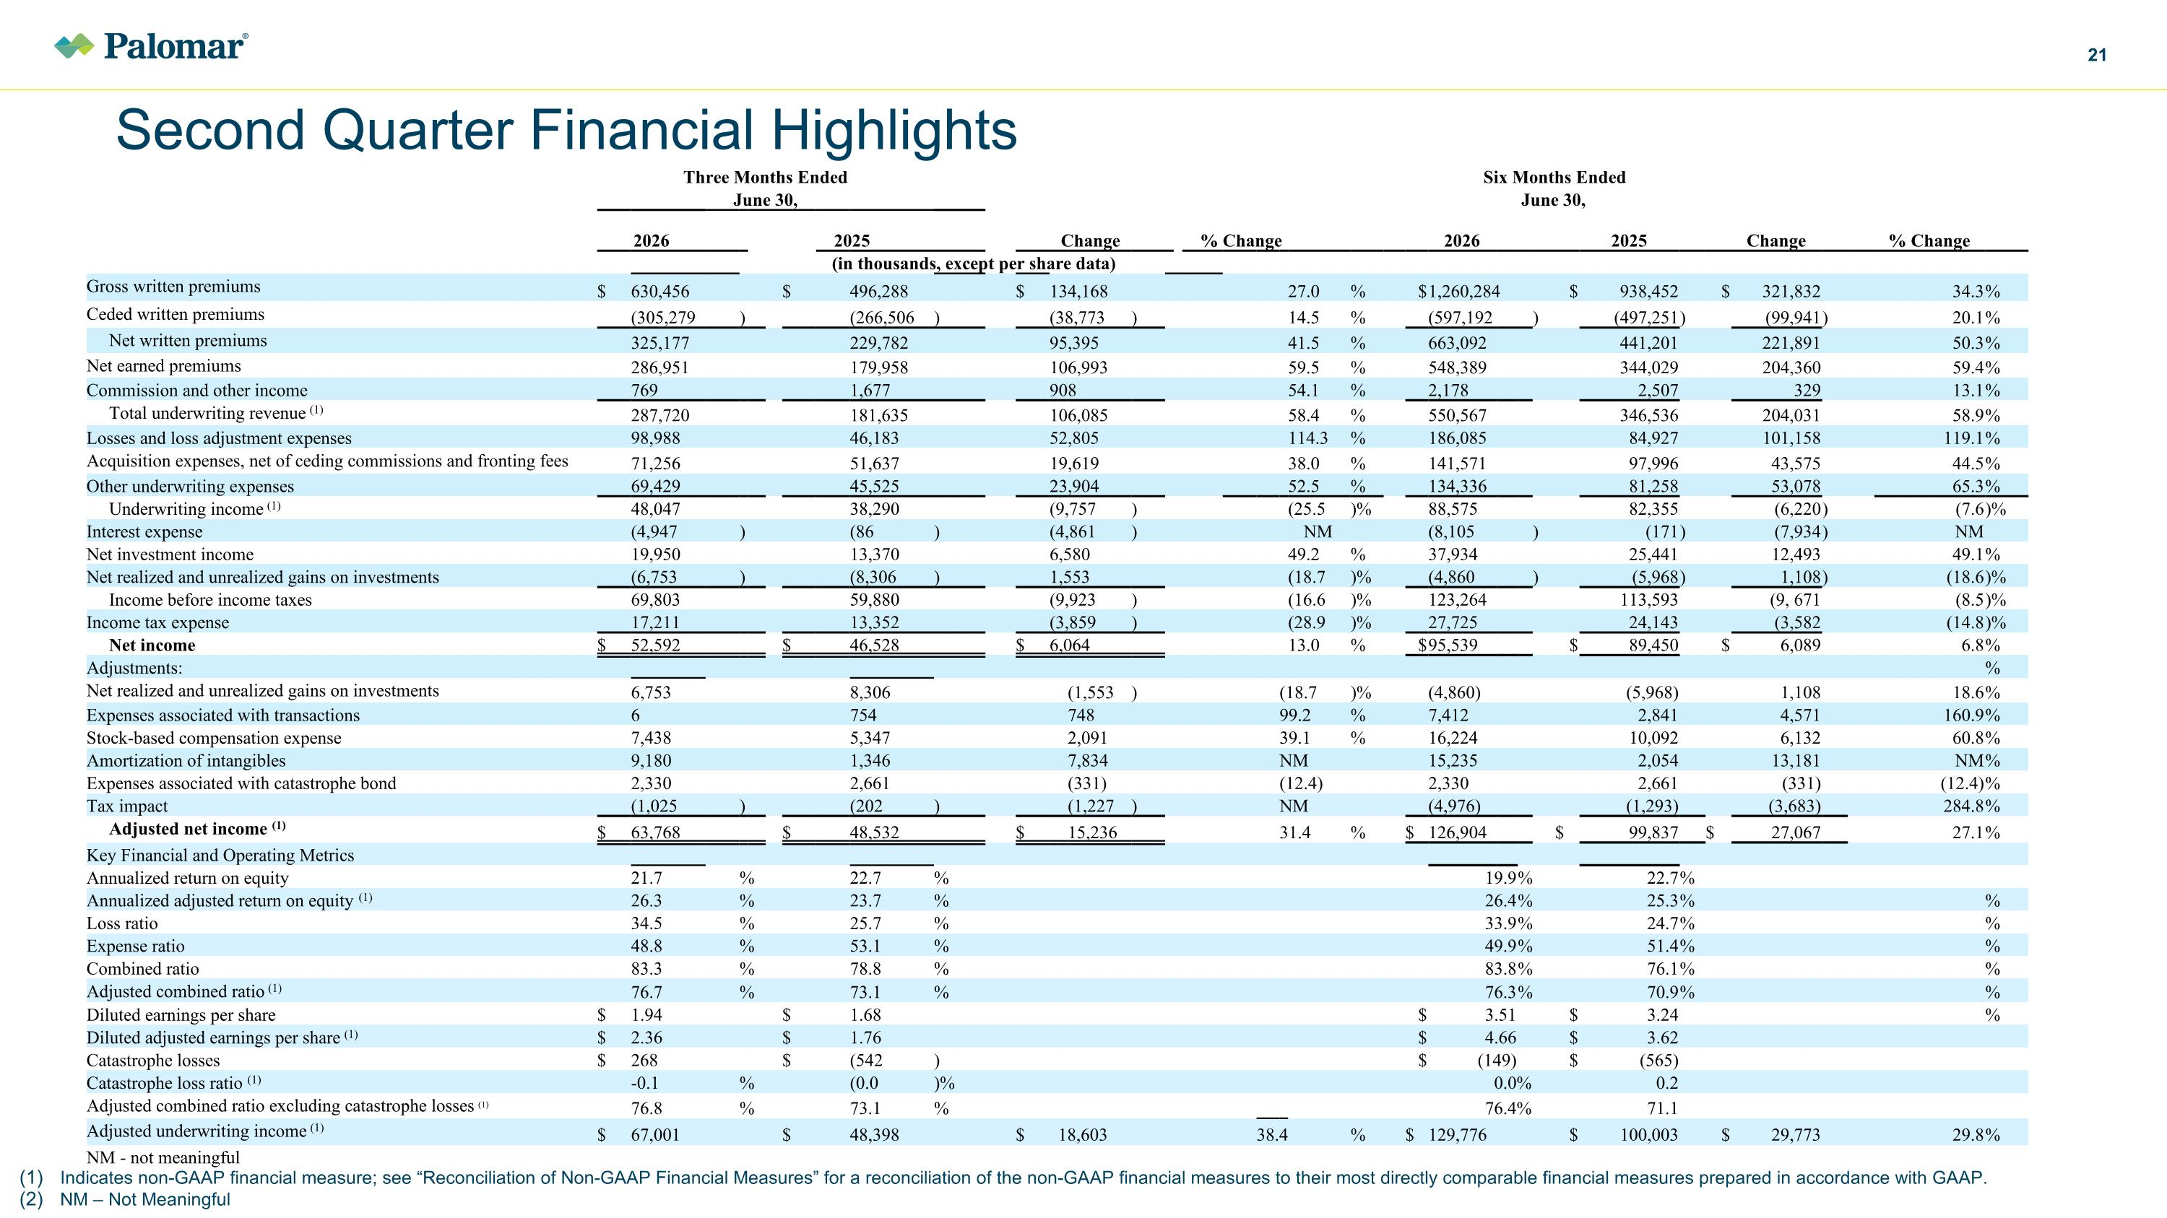
Indicates non-GAAP financial measure; see “Reconciliation of Non-GAAP Financial Measures” for a reconciliation of the non-GAAP financial measures to their most directly comparable financial measures prepared in accordance with GAAP. NM – Not Meaningful Second Quarter Financial Highlights Three Months Ended Six Months Ended June 30, June 30, 2026 2025 Change % Change 2025 2026 2025 Change % Change (in thousands, except per share data) Gross written premiums $ 630,456 $ $ 496,288 $ 134,168 27.0 27.0 % $ 1,260,284 $ 938,452 $ 321,832 34.3 % Ceded written premiums (305,279 ) (266,506 ) (38,773 ) 14.5 14.5 % (597,192 ) (497,251 ) (99,941 ) 20.1 % Net written premiums 325,177 229,782 95,395 41.5 41.5 % 663,092 441,201 221,891 50.3 % Net earned premiums 286,951 179,958 106,993 59.5 59.5 % 548,389 344,029 204,360 59.4 % Commission and other income 769 1,677 908 54.1 54.1 % 2,178 2,507 329 13.1 % Total underwriting revenue (1) 287,720 181,635 106,085 58.4 58.4 % 550,567 346,536 204,031 58.9 % Losses and loss adjustment expenses 98,988 46,183 52,805 114.3 114.3 % 186,085 84,927 101,158 119.1 % Acquisition expenses, net of ceding commissions and fronting fees 71,256 51,637 19,619 38.0 38.0 % 141,571 97,996 43,575 44.5 % Other underwriting expenses 69,429 45,525 23,904 52.5 52.5 % 134,336 81,258 53,078 65.3 % Underwriting income (1) 48,047 38,290 (9,757 ) (25.5 (25.5 )% 88,575 82,355 (6,220 ) (7.6 )% Interest expense (4,947 ) (86 ) (4,861 ) NM (8,105 ) (171 ) (7,934 ) NM Net investment income 19,950 13,370 6,580 49.2 % 37,934 25,441 12,493 49.1 % Net realized and unrealized gains on investments (6,753 ) (8,306 ) 1,553 (18.7 )% (4,860 ) (5,968 ) 1,108 ) (18.6 )% Income before income taxes 69,803 59,880 (9,923 ) (16.6 )% 123,264 113,593 (9, 671 (8.5 )% Income tax expense 17,211 13,352 (3,859 ) (28.9 )% 27,725 24,143 (3,582 (14.8 )% Net income $ 52,592 $ $ 46,528 $ 6,064 13.0 % $ 95,539 $ 89,450 $ 6,089 6.8 % Adjustments: % Net realized and unrealized gains on investments 6,753 8,306 (1,553 ) (18.7 )% (4,860) (5,968) 1,108 18.6 % Expenses associated with transactions 6 754 748 99.2 % 7,412 2,841 4,571 160.9 % Stock-based compensation expense 7,438 5,347 2,091 39.1 % 16,224 10,092 6,132 60.8 % Amortization of intangibles 9,180 1,346 7,834 NM 15,235 2,054 13,181 NM % Expenses associated with catastrophe bond 2,330 2,661 (331) (12.4) 2,330 2,661 (331) (12.4) % Tax impact (1,025 ) (202 ) (1,227 ) NM (4,976) (1,293) (3,683) 284.8 % Adjusted net income (1) $ 63,768 $ $ 48,532 $ 15,236 31.4 % $ 126,904 $ 99,837 $ 27,067 27.1 % Key Financial and Operating Metrics Annualized return on equity 21.7 % 22.7 % 19.9 % 22.7 % Annualized adjusted return on equity (1) 26.3 % 23.7 % 26.4 % 25.3 % % Loss ratio 34.5 % 25.7 % 33.9 % 24.7 % % Expense ratio 48.8 % 53.1 % 49.9 % 51.4 % % Combined ratio 83.3 % 78.8 % 83.8 % 76.1 % % Adjusted combined ratio (1) 76.7 % 73.1 % 76.3 % 70.9 % % Diluted earnings per share $ 1.94 $ $ 1.68 $ 3.51 $ 3.24 % Diluted adjusted earnings per share (1) $ 2.36 $ $ 1.76 $ 4.66 $ 3.62 Catastrophe losses $ 268 $ $ (542 ) $ (149) $ (565) Catastrophe loss ratio (1) -0.1 % (0.0 )% 0.0 % 0.2 Adjusted combined ratio excluding catastrophe losses (1) 76.8 % 73.1 % 76.4 % 71.1 Adjusted underwriting income (1) $ 67,001 $ $ 48,398 $ 18,603 38.4 % $ 129,776 $ 100,003 $ 29,773 29.8 % NM - not meaningful

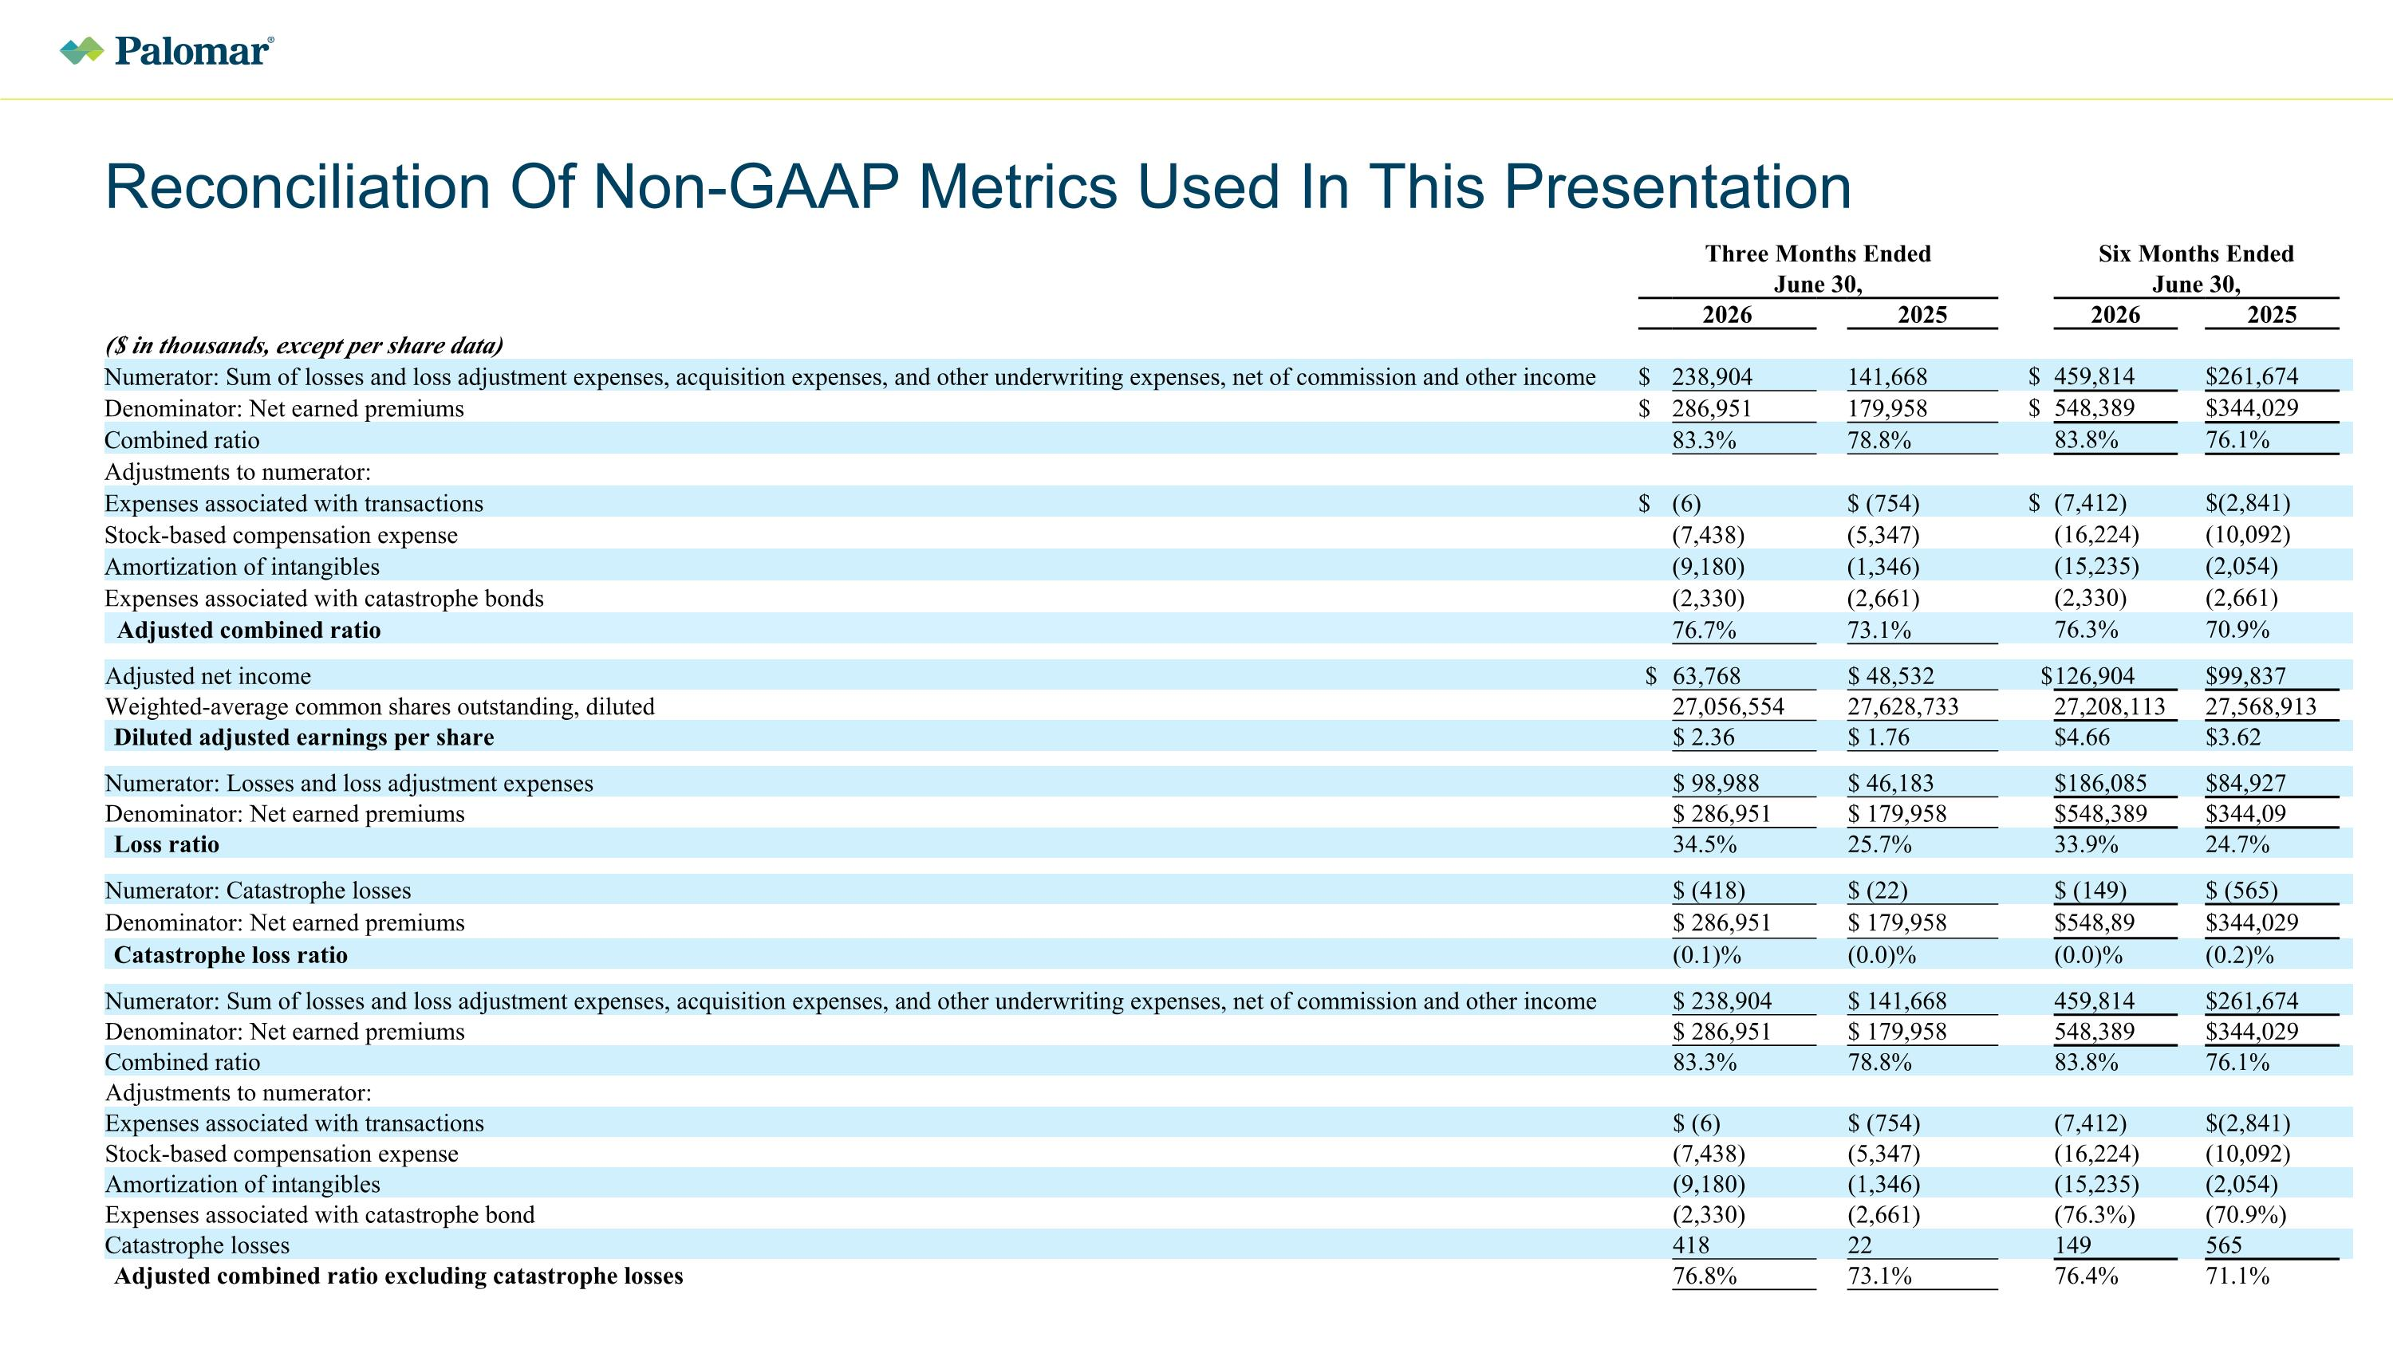
Reconciliation Of Non-GAAP Metrics Used In This Presentation Three Months Ended Six Months Ended June 30, June 30, 2026 2025 2026 2025 ($ in thousands, except per share data) Numerator: Sum of losses and loss adjustment expenses, acquisition expenses, and other underwriting expenses, net of commission and other income $ 238,904 141,668 $ 459,814 $261,674 Denominator: Net earned premiums $ 286,951 179,958 $ 548,389 $344,029 Combined ratio 83.3% 78.8% 83.8% 76.1% Adjustments to numerator: Expenses associated with transactions $ (6) $ (754) $ (7,412) $(2,841) Stock-based compensation expense (7,438) (5,347) (16,224) (10,092) Amortization of intangibles (9,180) (1,346) (15,235) (2,054) Expenses associated with catastrophe bonds (2,330) (2,661) (2,330) (2,661) Adjusted combined ratio 76.7% 73.1% 76.3% 70.9% Adjusted net income $ 63,768 $ 48,532 $ 126,904 $99,837 Weighted-average common shares outstanding, diluted 27,056,554 27,628,733 27,208,113 27,568,913 Diluted adjusted earnings per share $ 2.36 $ 1.76 $4.66 $3.62 Numerator: Losses and loss adjustment expenses $ 98,988 $ 46,183 $186,085 $84,927 Denominator: Net earned premiums $ 286,951 $ 179,958 $548,389 $344,09 Loss ratio 34.5% 25.7% 33.9% 24.7% Numerator: Catastrophe losses $ (418) $ (22) $ (149) $ (565) Denominator: Net earned premiums $ 286,951 $ 179,958 $548,89 $344,029 Catastrophe loss ratio (0.1)% (0.0)% (0.0)% (0.2)% Numerator: Sum of losses and loss adjustment expenses, acquisition expenses, and other underwriting expenses, net of commission and other income $ 238,904 $ 141,668 459,814 $261,674 Denominator: Net earned premiums $ 286,951 $ 179,958 548,389 $344,029 Combined ratio 83.3% 78.8% 83.8% 76.1% Adjustments to numerator: Expenses associated with transactions $ (6) $ (754) (7,412) $(2,841) Stock-based compensation expense (7,438) (5,347) (16,224) (10,092) Amortization of intangibles (9,180) (1,346) (15,235) (2,054) Expenses associated with catastrophe bond (2,330) (2,661) (76.3%) (70.9%) Catastrophe losses 418 22 149 565 Adjusted combined ratio excluding catastrophe losses 76.8% 73.1% 76.4% 71.1%

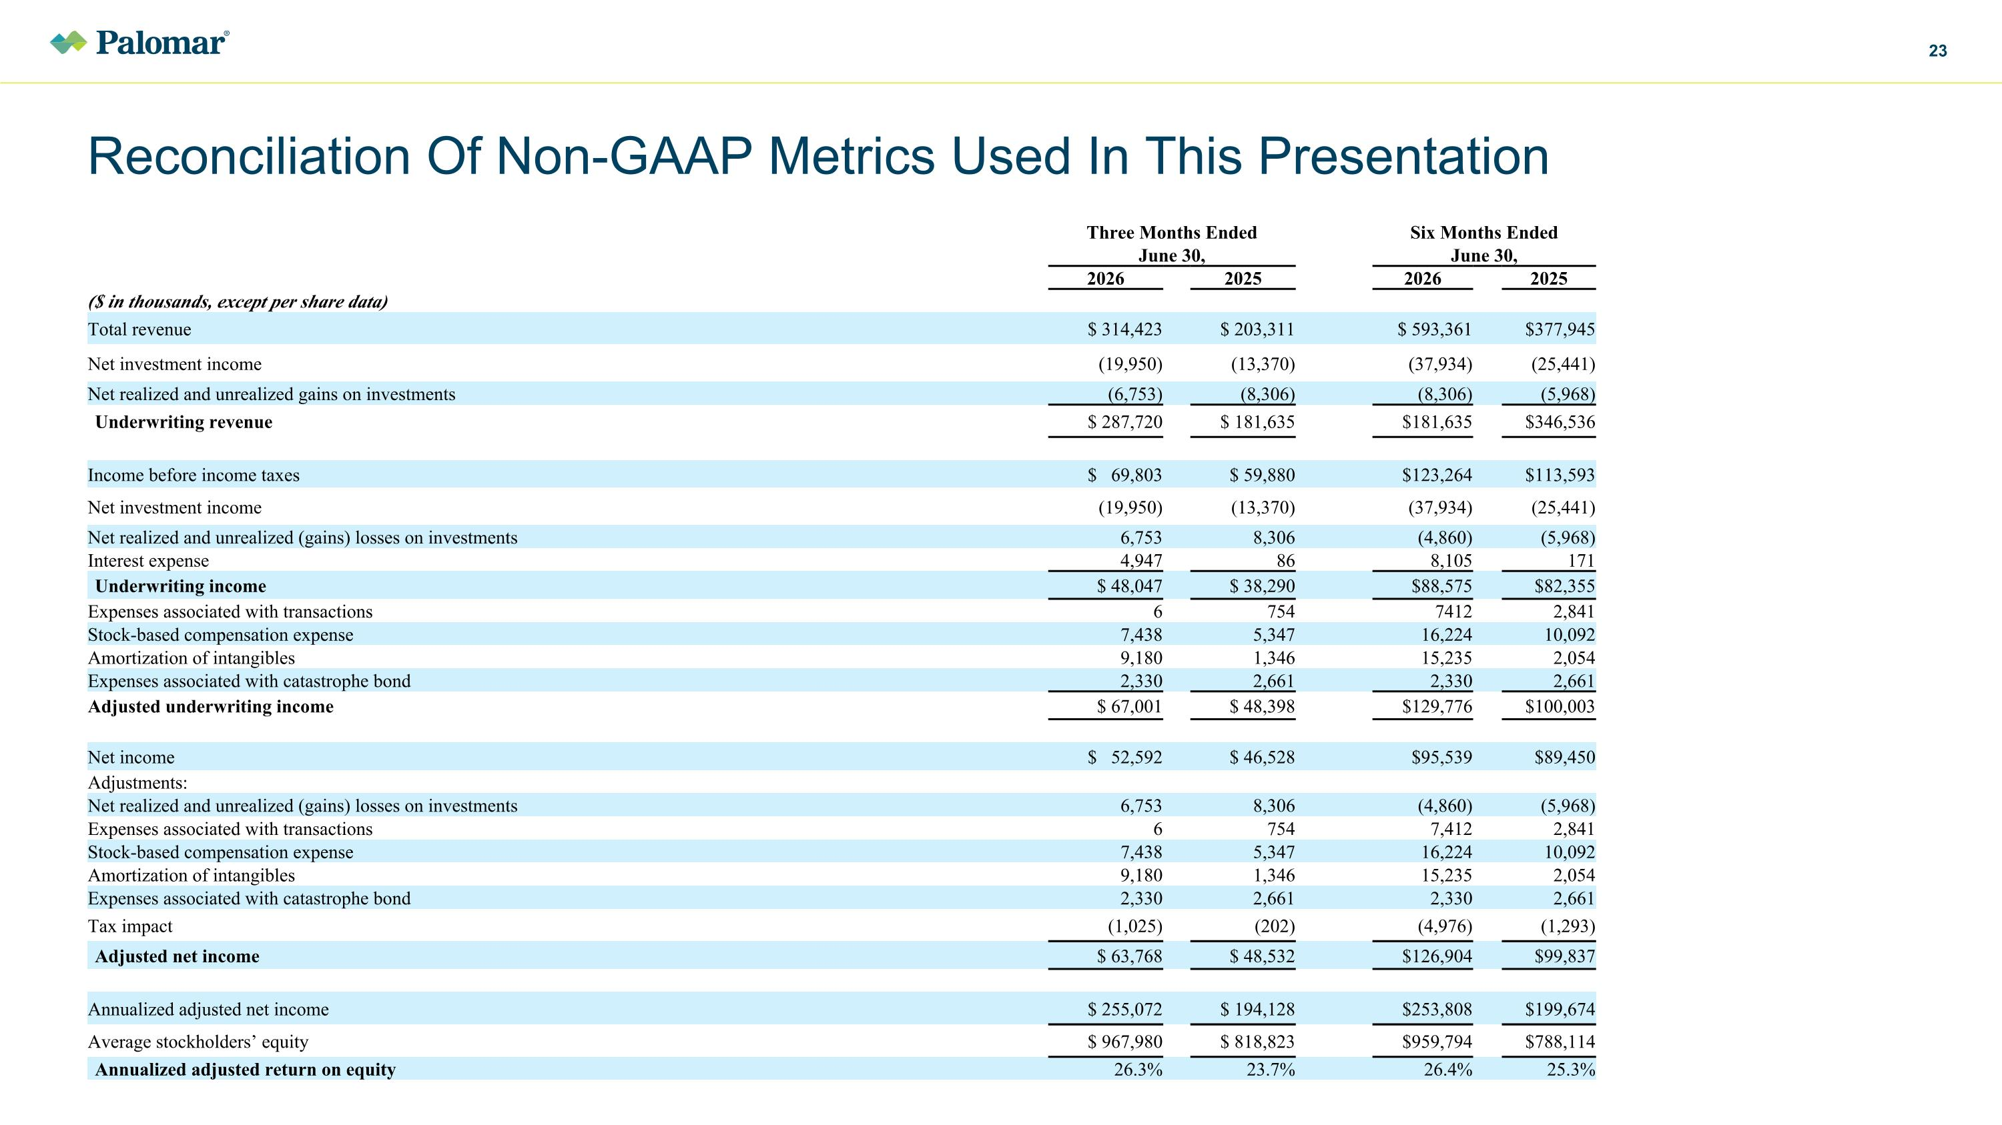
Reconciliation Of Non-GAAP Metrics Used In This Presentation Three Months Ended Six Months Ended June 30, June 30, 2026 2025 2026 2025 ($ in thousands, except per share data) Total revenue $ 314,423 $ 203,311 $ 593,361 $377,945 Net investment income (19,950) (13,370) (37,934) (25,441) Net realized and unrealized gains on investments (6,753) (8,306) (8,306) (5,968) Underwriting revenue $ 287,720 $ 181,635 $181,635 $346,536 Income before income taxes $ 69,803 $ 59,880 $123,264 $113,593 Net investment income (19,950) (13,370) (37,934) (25,441) Net realized and unrealized (gains) losses on investments 6,753 8,306 (4,860) (5,968) Interest expense 4,947 86 8,105 171 Underwriting income $ 48,047 $ 38,290 $88,575 $82,355 Expenses associated with transactions 6 754 7412 2,841 Stock-based compensation expense 7,438 5,347 16,224 10,092 Amortization of intangibles 9,180 1,346 15,235 2,054 Expenses associated with catastrophe bond 2,330 2,661 2,330 2,661 Adjusted underwriting income $ 67,001 $ 48,398 $129,776 $100,003 Net income $ 52,592 $ 46,528 $95,539 $89,450 Adjustments: Net realized and unrealized (gains) losses on investments 6,753 8,306 (4,860) (5,968) Expenses associated with transactions 6 754 7,412 2,841 Stock-based compensation expense 7,438 5,347 16,224 10,092 Amortization of intangibles 9,180 1,346 15,235 2,054 Expenses associated with catastrophe bond 2,330 2,661 2,330 2,661 Tax impact (1,025) (202) (4,976) (1,293) Adjusted net income $ 63,768 $ 48,532 $126,904 $99,837 Annualized adjusted net income $ 255,072 $ 194,128 $253,808 $199,674 Average stockholders’ equity $ 967,980 $ 818,823 $959,794 $788,114 Annualized adjusted return on equity 26.3% 23.7% 26.4% 25.3%

